University of the West of Scotland
School of Computing, Engineering and Physical Sciences

Design and Implementation of an Automated CI/CD Pipeline with Integrated DevSecOps Practices

Student name: Shahid Rasool

Banner ID: B01801311

Programme: MSc Information Technology (DevOps)

Supervisor: Fath Ullah

Date of Submission:

Table of Contents
1. Introduction 6
1.1. Background 6
1.2. Gap in Current Practice 7
1.3. Research Aim and Research Question 8
1.4. Project Objectives 8
1.5. Structure of the Report 8
2. Literature Review / Background Research 10
2.1. Introduction 10
2.2. CI/CD Fundamentals 10
2.3. DevOps Principles 11
2.3.1. Teamwork and Co-ownership. 11
2.3.2. Automation of Build, Test, and Deployment 12
2.3.3. Constant Monitoring and Feedback 12
2.3.4. Infrastructure-as-Code (IaC) 12
2.3.5. Culture of Innovation and Improvement 12
2.4. DevSecOps 13
2.4.1. Key DevSecOps Practices 13
2.4.2. DevSecOps Tool Categories 14
2.4.3. Research Gap 14
2.5. Tool Comparisons 14
2.5.1. CI/CD Automation Tools 14
2.5.2. Containerization Tools 15
2.5.3. Security Tools 16
2.5.4. Infrastructure-as-Code (IaC) Tools 17
2.6. Project Overview of Gaps that the Project will fill. 17
3. Methodology 19
3.1. Research Design 19
3.2. Tools to be used and the justification 20
3.2.1. CI/CD Automation Tools 20
3.2.2. Containerization Tools 20
3.2.3. Security Tools 20
3.2.4. Infrastructure-as-Code Tools 21
3.3. Pipeline Design Approach 21
3.4. Data sources and the data collection 22
3.4.1. Quantitative Data 22
3.4.2. Qualitative Data 23
3.5. Strategy for the implementation of the plan 23
3.6. Ethical Considerations 24
3.7. Evaluation Methodology 25
3.8. Chapter Summary 26
4. Implementation / Case Study 27
4.1. Week 1 and 2 27
4.2. Week 3 Tool Selection 27
4.3. Week 4 and 5: Pipeline Design 28
4.4. week 6 and 8 CI/CD Implementation. 29
4.5. Week 9-10 and 11 32
4.6. Week 12 33
4.7. Week 13-15 33
4.7.1. The creation of the DevSecOps-Pulse 34
5. Evaluation 38
5.1. Introduction 38
5.2. Performance Comparison: Pipeline and Manual Process 39
5.2.1. Manual Process Overview 39
5.2.2. CI/CD Pipeline Overview 40
5.2.3. Comparative Metrics 41
5.3. Metrics Evaluation 41
5.3.1. Build Time 42
5.3.2. Vulnerability Detection 43
5.3.3. Deployment Success Rate 43
5.3.4. Efficiency Improvement 44
5.4. Discussion of Results 45
5.4.1. Limitations 46
5.5. Quantitative Summary 46
5.6. Conclusion 47
5.7. DevSecOps-Pulse Dashboard Evaluation 47
6. Discussion 48
6.1. Synthesis of Findings and Theoretical Alignment 48
6.2. The DevSecOps-Pulse Product: The Next Research Scope 48
6.3. Balancing Automation with Practical Challenges 49
6.4. Practice and Future Research Implications 49
6.5. Conclusion of Discussion 50
7. Conclusion and Recommendations. 51
7.1. Summary 51
7.2. Achievements 51
7.3. Future Work Recommendations 51
8. Critical Self-Evaluation 52
8.1. Introduction 52
8.2. Knowledge and Learning Outcomes 52
8.3. Challenges Faced and Overcome 52
8.4. Skills Developed 53
8.5. Areas for Improvement 54
8.6. Conclusion 54
9. References 55

Abstract
The proposed project will be dedicated to the design and deployment of an automated Continuous Integration and Continuous Deployment (CI/CD) pipeline with the integration of DevSecOps practices aimed at improving the speed of software delivery, its reliability, and security. Security has been added at the later parts of the software development life cycle in most of the traditional development settings leading to delays, more vulnerability and reliance on manual controls. In an attempt to address these constraints, the suggested solution entails the integration of security checks as a part of the whole pipeline, which allows the localization of problems earlier and reduces threats related to fixing the pipeline at the end of the day. The pipeline is also configured with automated build, test, security scan and deployment that relies on industry-standard tools such as GitHub Actions, Jenkins, Docker, SonarQube, Trivy and OWASP Dependency Check. IaC tools, like Terraform and Ansible, provide consistency, reproducibility, and on-demand capability to deploy environment.
The pipeline is implemented and tested using a sample web application, and the data gathered is in the form of build logs, vulnerability reports, deployment times and security metrics. The comparative analysis of the secure automated pipeline and the conventional or non-secure methods illustrates significant enhancement in the ability to detect vulnerabilities, the accuracy in deployment, and the general efficiency of the operations. The automated security scanning is heavily used to lessen the amount of manual work and enhance the frequency and dependability of deployments. The results affirm that integrating DevSecOps practices into CI/CD pipelines is a viable and useful approach to enhancing the security posture and performance of the current software development processes. The project offers a scalable, replicable framework that can be used in organizations to implement secure, scalable and full automation of software delivery processes.

Introduction

Background

In the last ten years, there has been a paradigm shift in the software development industry in terms of the traditional sequential schemes of release to the fast and iterative models of delivery. Software systems are now required by organisations to keep on developing and to introduce new functions at brief intervals and to respond to user request nearly immediately. This has been enabled to a large extent by the usage of the Devops principles where the development and the operations teams work hand in hand to optimize the Software Development Life Cycle (SDLC). One of the facts that arise as a result of this change is the proliferation of Continuous Integration (CI) and Continuous Deployment (CD) pipelines, which automate major operations including building, testing, packaging, and deploying software.
CI/CD pipelines enhance the efficiency of the development process through the provision of an automatic validation and deployment of all code changes in a uniform way. This automation will save manpower, reduce errors and deploy more frequently- organisations can provide updates on a daily or even hourly basis. Because of it, CI/CD has become a core competency in the present-day engineering teams, allowing software delivery that is predictable, repeatable, and scaleable.
The speedy pace at which software is delivered, however, has created new security issues. With organisations making an effort to release faster, there will be high chances of launching insecure code, vulnerable dependencies or misconfigured cloud resources. Conventionally, security inspections are done at the close of the SDLC after the development and testing processes have been done. This security at the end design is a common source of latent vulnerability discovery, high cost remediation processes, and product delay. Additionally, the emergence of containerization, micro services, and cloud-native architecture has established more points of exposure where misconfigurations or old images can cause serious security threats. DevSecOps is one such solution to these issues. DevSec operations, unlike the traditional security models, incorporate security practices at all stages of the CI/CD pipeline. This methodology, which is often referred to as shifting security left, focuses on the automation process, constant monitoring, and proactive vulnerability.
DevSecOps promotes teams to incorporate security scans, code quality checks, policy compliance and enforcement at the early pipeline stages and continuously. With the integration of these tools like SonarQube, Trivy, OWASP Dependency Check, and automated secrets scanning, organisations will minimize the likelihood of introducing the vulnerabilities in the production environments by a significant margin.
With this changing environment, the incorporation of DevSecOps in CI/CD pipelines is no longer desirable, but also necessary. Why CI/CD + DevSecOps Matters

The DevSecOps integration into a CI/CD pipeline has valuable technical, operational, and organizational implications.
Early Detection of vulnerabilities: SonarQube, Trivy, Snyk, and OWASP Dependency Check are automated tools that enable teams to identify insecure code usage, libraries with obese dependencies, misconfigured Dockerfiles and vulnerable container layers. Correcting these problems at the earliest stage of their occurrence, often during the time of committing an error, allows saving a lot of money and effort that would be used to solve such problems.
Increased Reliability and Less Deployment Failures: CI/CD pipelines automate unit test, integration test, and environment validation. Combining them with DevSecOps controls, organisations will have an increased level of assurance that every release addresses both functional and security needs. This minimizes rollback of deployment and disruption of operation.
The security has not been compromised to achieve faster deliveries. Conventional security procedures slow down deployment since teams perform manual inspection and audits towards the end in development. DevSecOps eliminates this bottleneck through constant and automatized security checks.
Constant Compliance and Governance: Lots of industries, such as healthcare, finances, and government, need to meet the standards like HIPAA, GDPR, ISO 27001, and PCI DSS as well as organizational security policies. DevSecOps allows policy to be enforced throughout the development process to assist organisations with non-compliance risks.
Replicable and Scalable Infrastructure: The emergence of infrastructure-as-Code (IaC) tools such as Terraform and Ansible allows to recreate an environment with certainty when used in development, staging, and production.
On the whole, the DevSecOps concept should be implemented into CI/CD to help organisations and their clients provide secure, reliable, and rapidly evolving software solutions.

Gap in Current Practice

Although CI/CD becomes more and more popular, a number of gaps are identified in the real-world implementation.
Security is Added Late into Process: Most organisations still perceive security as the last phase instead of considering it as a component of development. Consequently, vulnerabilities are pointed out after code has been developed.

Relying on Manual Reviews and Reactive Leadership: Manual security assessment creates delays and can result in inconsistent assessment. Teams who are not automated cannot keep the speed and security.
Minimal Cooperation between Security and Development Team: The conventional organizational set-ups tend to isolate security teams, causing communication barriers, conflicting priorities as well as slow response cycles.
Absence of Automated Scanning of current risks: Most of the pipelines in use lack automated scanning of insecure coding practices weak external requirements. Container image vulnerabilities refer to issues with container images that can be exploited to compromise the security of the system running them. Container image vulnerabilities are problems with container images that may be used to undermine the security of the system in which they are executed. hard coded secrets and tokens incorrectly configured infrastructure and cloud systems.
A Lack of Academic Model and Case study: Whereas industry literature contains guidelines related to each tool, scholarly literature lacks practical, real-world, end-to-end, illustrations of a current DevSecOps-enabled CI/CD pipeline.
These loopholes demonstrate that there is a necessity to design a well-organized, fully-automated implementation where security is incorporated into all steps of the CI/CD process. The project aims at addressing this gap by offering a practical, reproduced and full pipeline architecture supported by evaluation metrics.

Research Aim and Research Question

Research Aim This project proposal aims to develop, deploy, and test an automated CI/CD pipeline with the use of DevSecOps principles to increase the speed, reliability, and safety of software delivery.
Research Question What can be done to integrate the DevSecOps practices effectively into an automated CI/CD pipeline to improve the speed, reliability, and security of the software delivery?

Project Objectives

To reach the research aim and answer the research question, the following objectives are set in the project:
- Complete a thorough literature review of DevOps, CI/CD, DevSecOps, IaC and security automation.
- Find existing constraints and practice of secure software delivery. Create an end-to-end CI/CD design which incorporates automated security throughout the pipeline stages.
- Automated builds and testing CI/CD processes with GitHub Actions or Jenkins.
- Containerize the application with Docker and add vulnerability scanner tools, e.g. Trivy.
- Deploy reproducible and secure environments with Infrastructure-as-Code tools (Terraform, Ansible).
- Gather the performance statistics, logs and scan findings to analyze them.
- Compare automated DevSecOps pipeline to a traditional CI/CD pipeline (lacking security integration).
- Recommend, conclude and offer future enhancement of safe automation.

Structure of the Report

The report has been structured into seven chapters that aim at developing a holistic view of how automated CI/CD pipeline combined with DevSecops principles can help increase the speed, reliability and security to deliver software.
In Chapter 2, the Literature Review in detail is presented, analyzing the available literature on the topic of DevOps, CI/CD practices, DevSecOps frameworks, Infrastructure-as-Code practices and security automation tools. It brings out the existing trends in the industry, technology standards, and gaps in the current academic literature.
Chapter 3 provides description of the Methodology applied in the project, which covers the research design, system architecture planning, tools selection, data collection strategy, and evaluation criteria to be used in comparison of secure and non secure pipelines. The Implementation chapter
Chapter 4 gives a detailed step-by-step account of the process of creating the pipeline, which includes the configuration of the CI/CD workflow, Docker containerization, integrating security scanners SonarQube, Trivy, and OWASP Dependency Check and using Terraform and Ansible to provision an environment based on IaC.
Chapter 5 lays out the Results and Analysis, reflecting build metrics, vulnerability data, performance data, and comparative information between secure pipelines that have DevSecOps and regular CI/CD workflows. It addresses some of the important findings on efficiency gains, risk minimization and reliability gains realized in case of security automation.
Chapter 6 provides a Discussion of the findings, unfolding their overall meaning to the real-world situation and limitations, restrictions, and implications towards engineering teams that implemented DevSecOps practices.
Lastly, Chapter 7 wraps up the report with a summary of significant contributions, answers to the research question, and recommendations on what can be improved in the future such as a move to more advanced automation, integrating policy-as-code, and scaling DevSecOps in enterprise-level.

Literature Review / Background Research

Introduction

The past decade has seen radical change in modern software engineering, abandoning sluggish, detached and frequently manual development processes in place of highly-automated, collaborative and agile ecosystems of delivery. Conventional models of software development including the Waterfall model, were based on the sequential stages in which the requirements, design, development, testing, and deployment were viewed as separate processes. These methods were also subject to delays, human factor, integration problems and could not always manage to match with the dynamism of business demands. On the contrary, modern approaches to development focus on automation, constant feedback, and cross-functional teamwork that allows organisations to be more responsive to the needs of the market, customer expectations, and new technological developments.
One of the key factors that have led to the change has been the implementation of the DevOps concepts and CI/CD (Continuous Integration and Continuous Deployment) models. The practices are meant to close the historical divide between the operations and software development teams and create a culture of collaboration, shared responsibility and faster delivery. CI/CD pipelines enable development teams to incorporate changes regularly and test using automated methods and deploy new functionality and bug fixes in a consistent and reliable manner.
In line with this fast technological development security has become a burning issue. Traditional models were used to consider security as a last-minute operation and is usually done prior to production deployment. Such a security lasts strategy results in the identification of vulnerabilities later in time, high costs incurred during remedies as well as high operational risks.
To overcome these issues the DevSecOps paradigm has developed that incorporates security in all phases of the development lifecycle. DevSecOps encourages proactive security measures, such as automated code checks, vulnerability checks, compliance checks, and secure deployment, and thus, software is not only reliable but also securely deployed in the first place. A combination of security in CI/CD pipeline enables organisations to lower the risks of failures in production, reinforce compliance, and preserve integrity of quickly developing software systems.

CI/CD Fundamentals

Continuous Integration (CI) and Continuous Deployment (CD) are the foundations of the contemporary software delivery pipelines, which allow the teams to continue their high productivity, quality, and agility. Continuous Integration is all about the numerous integration of code changes to a central repository. Each commit will show automated processes of compilation, unit testing, static code analysis and integration testing. CI has the following main objectives, early identification of integration problems, lessening the amount of conflict between code branches, and maintaining a state of always being deployable. Through the application of CI, teams eliminate the integration hell that happens during the conventional development cycles, where integrating large volumes of changes at the end of a development cycle usually causes serious delays and bugs.
Such tools as Jenkins, GitHub Actions, GitLab CI/CD and CircleCI are quite popular, offering powerful automation to CI processes. The tools enable developers to specify workflows and run tests in a variety of environments and produce advanced reports that make teams aware of the build status, code quality, and possible problems. Automated CI processes encourage high feedback rates so developers are able to fix defects almost as soon as they occur, thus increasing the overall quality of software and decreasing the time taken to debug and test.
Continuous Deployment builds on CI by automating the deployment of successfully tested builds to staging or production systems. In contrast to manual processes used to deploy the software, which are slow and prone to errors, CD makes sure that software updates are added continuously, consistently, and with the least amount of human interference. Continuous Delivery is a type where a deployment to production can be manually approved, but all artifacts are ready to be deployed to production. CI and CD are also highly reliant on automation such as version control systems, testing frameworks, container orchestration and environment provisioning to ensure the integrity and reliability of the pipeline.
More recent CI/CD pipelines have also adopted containerization technology, including Docker, orchestration technology, including Kubernetes and versioned binary artifact repositories, and automated environment provisioning. Such integrations allow development teams to have predictable deployments, multi environments consistency, fast roll back and even scalable operations.
Unless pipelines are built with inbuilt security measures, they may unwillingly introduce vulnerabilities, misconfigurations and exposing secrets into the production environment. This diversification has led to the development of DevSecOps, which integrates security into the entire CI/CD processes without causing the speed of delivery to compromise the integrity of the application or the laws and regulations.

DevOps Principles

Devops is a technical and cultural trend intended to integrate software development (Dev) and IT operations (Ops) in order to deliver software in a faster, more reliable, and efficient way. The traditional development processes tended to be separated into teams that worked independently with developers creating the code, testers testing the code, and the operations teams taking care of the deployment and infrastructure services. Such a siloed manner of operation resulted in extended feedback loops, deployment inconsistencies, recurring miscommunications, and inefficient operations. DevOps

Teamwork and Co-ownership.

The essence of DevOps inherently involves going hand in hand with cross-functional teams of developers, operations engineers, testers, and more and more security professionals. The co-existence of the different stages of the development lifecycle design, development, testing, deployment and monitoring is in tandem with the organizational objectives. The responsibility is shared in teams on code quality, deployment reliability and system performance.

Automation of Build, Test, and Deployment

The underlying principle of DevOps is automation that will remove manual repetitive and error-prone processes. Automation of building, testing, packaging and deploying applications can enable organisations to maintain uniform, repeatable as well as predictable results. This automation is promoted through CI/CD pipelines, automated scripts, and configuration templates. Automated testing makes sure that the change of codes is checked at all times and there is less possibility of bugs and failure of integration. The deployment automation, along with rollback mechanisms ensures that the applications are able to be delivered within a short time, without affecting quality. Automation also enables scales of operations to be done efficiently and time spent on higher-level tasks of innovation, optimization, and problem-solving.

Constant Monitoring and Feedback
The constant monitoring gives instant access to the performance of applications, system health, error rates, as well as the utilization of infrastructure. Applications such as Prometheus, Grafana, ELK Stack (Elasticsearch, Logstash, Kibana) and Datadog allow organisations to gather measurements, provide alerts, and monitor production system abnormalities. The monitoring feedback is looped back to the development and operations teams, allowing the identification of problems proactively and their subsequent enhancement.

Infrastructure-as-Code (IaC)

In IaC, the infrastructure is specified and operated by machine-readable configuration files instead of by hand. Terraform, Ansible and Cloud Formation are tools that can be used to automatically provision servers, networks, load balancers and security policies. IaC provides consistency of the environment during the phases of development, testing, staging and production, removing configuration drift and minimizing errors during deployment. The ability to version IaC scripts enables a team to follow the changes, undo the update, and keep the reproducible environment, which is aligned with the concepts of DevOps automation and constant delivery.

Culture of Innovation and Improvement

DevOps encourages experimentation, quick iteration and constant improvement. Post-deployment retrospectives, analysis of blameless incidents, and performance reviews assist the teams in establishing bottlenecks, inefficiencies, and possible optimization. Such a culture promotes innovation and minimizes errors that may happen repeatedly and enhances reliability of the entire system. Through constant learning on failures and success, organisations are able to refine their pipelines, processes and practices, developing a robust and dynamic development environment.
Though DevOps significantly increases the speed of delivery, quality, and collaboration, the security aspect in traditional DevOps activities is not emphasized leading to pipelines being exposed to dependency exploits, misconfigurations, container vulnerabilities, and supply chain attacks. DevSecOps builds on the concept of DevOps to incorporate the concept of security into all stages of the CI/CD pipeline, and provide a comprehensive approach to the delivery of secure software.

DevSecOps

Tools, best practices, research gap (Expanded) DevSecOps (Development, Security and Operations) A development of DevOps, which explicitly includes security in the software delivery process. Its philosophy is the shift-left security, which focuses on vulnerability detection and mitigation as early as possible during the development, instead of trying to fix it at the end of the deployment. DevSecOps can help organisations deliver applications in a short time by ensuring security practices are embedded in the pipelines of the CI/CD processes without affecting integrity, reliability, or compliance.

Key DevSecOps Practices

Automated security Scanning: Security scanning is also a part of every phase of the CI/CD pipeline to address the problems in advance. These are the insecure patterns of code, the vulnerable third party dependencies, the vulnerable images, and the vulnerable misconfigurations. Applications like SonarQube, Trivy and OWASP Dependency-Check include automated scanning and reporting features that allow the teams to fix vulnerabilities in a short time and remain in compliance.
Secrets Management: A security weakness is the hardcoding of credentials, API keys and tokens in the source code. DevSecOps promotes the use of secure secrets management by the means of vaults and encrypted storage systems. GitHub Actions Secrets, HashiCorp Vault, AWS Secrets Manager, and Azure Key Vault are very popular to protect sensitive data and secrets are injected in a secure manner when running them without leaving the information in the code repository.
Compliance Automation: Automated audits, policy checks and configuration verification are regulatory and organizational compliance. Open Policy Agent (OPA), Checkov, and Terraform Validator are some tools that can analyze the code and infrastructure setups based on predetermined policies and ensure that the setups comply with security standards, best practices, and industry regulations.
On-going Security Surveillance: Container monitoring tools can monitor container behavior, API calls, and network traffic, discovering suspicious behavior, security attacks, or policy violations, on a real-time basis. Falco-, Aqua Security-, and Sysdig allow detecting and fixing the incidents quickly and proactively, which strengthens the overall security aspects of applications.

DevSecOps Tool Categories

Administered to Static Application: Tests source code against vulnerability, insecure coding patterns or anti-patterns. Example: SonarQube.
Software Composition Analysis (SCA): Identifies vulnerabilities in third party libraries, dependencies and packages. Case study: OWASP Dependency Check.
Container Vulnerability Scanning: Checks Docker and OCI images against malconfigurations, insecure packages, and known vulnerabilities (CVEs). Example: Trivy
IaC Security Tools: Check infrastructure settings using security and compliance. Examples Checkov, Terraform Validator.

Research Gap

Even with the vast use of DevOps, there are still considerable gaps in practice and scholarly literature:
- Security tends to be introduced towards the end of the development cycle whereby the risk is not minimized.
- Scalability is hampered by the fact that manual code reviews and security testing are still much used.
- Studies can be based on the individual tools instead of showing end-to-end automated pipelines.
- The use of practical and hands-on academic examples that combine CI/CD, containerization, and DevSecOps controls are few.
- There is a lack of guidelines on how IaC security checks can be incorporated into CI/CD processes.
- There is limited empirical research on the effects of security automation regarding performance and deployment.
The proposed project is an attempt to fill these gaps by creating, deploying, and assessing a completely automated CI/CD pipeline that incorporates DevSecOps at each phase of the pipeline.

Tool Comparisons

This part gives a comparative analysis on the most popular tools used in contemporary CI/CD pipelines and DevSecOps practices in detail. The right software delivery tools are a decisive factor to ensure efficiency, security and reliability of automated software delivery. All types of tools, i.e. CI/CD automation, containerization, security scanning, and infrastructure-as-code, serve different purposes such as ensuring that the code can be transferred between development and production without breaching the high quality and security standards.

CI/CD Automation Tools

GitHub Actions: The GitHub Actions is an automation platform of workflows, which are integrated into the GitHub repositories. Its main role is to allow software build, testing and deployment to be automated right in the source code repository. GitHub action is based on the YAML files that describe workflows that execute when an event occurs like push, pull requests or a job schedule.
Strengths of GitHub Actions:
Embedded Runners and Multi-Platform Support: GitHub offers runners that are pre-configured to run on a variety of environments various operating systems, such as Linux, Windows, and macOS, and developers do not have to do any extra work to test their code on those environments.
Marketplace of Pre-Built Actions: An ecosystem of available reusable actions exists in the community that can be directly integrated into workflows and save set up time and boost productivity.
GitHub Integration: The close interaction with pull requests, issues, and repositories is provided to enable automated code reviews and status updates and notifications.
Simplicity of Implementation and Support: Workflow implementations are pretty straight forward and require minimum infrastructure as it is completely hosted on GitHub cloud.
Limitations: Although GitHub Actions is a good tool when it comes to small to medium-sized projects, it does not offer much in terms of enterprise-level customization as Jenkins does. Multiple repositories may have to be orchestrated in a complex manner, potentially necessitating further workaround.
Jobs which use GitHub runners are limited in terms of resource allocation and running multiple jobs at the same time, potentially affecting very large-scale projects.
Jenkins is a pluggable system and thus it could be considerably customized to fit into a particular project.
Strengths of Jenkins: Ability to be highly customizable Jenkins pipelines may be either completely customized using Groovy scripts or declarative pipelines. The ability to easily reach complexity of orchestration, execute in parallel processes, and integrate with outside tools is easily attained.
Large Plugin Ecosystem: There are thousands of plugins that can be used to connect with version control systems, build tools, testing frameworks, containerization platforms and security tools.
Complex Pipe Work Support: Jenkins can support highly complex workflows with many branches and environments and conditional steps, which is why it is best suited to an enterprise level software delivery.
Limitations: Jenkins will need self-managed servers, frequent maintenance and updates on the plugins. This may augment administrational overhead.

Containerization Tools

Docker: Docker is the most popular containerization platform whereby applications are packed with their dependencies and then moved in lightweight, portable containers. Containers provide the ability to maintain consistency between the various environments of the application and remove the issue of it working on my machine.
Key Benefits:
Portability: Docker ensures that applications run identically in the development, testing, and production environments by wrapping them in all the libraries and dependencies that they need to run.
Portability and Scalability: Containers have no modifications that need to be made before they can be deployed on a local machine or on-premises or on a cloud infrastructure. This increases scalability and eases the architectures of micro services.
Lightweight Isolation: Docker has isolated execution environments with low overhead rates in comparison with traditional virtual machines.
Limitations: Images are not scanned or updated and containers might introduce security risks. System can be compromised by unpatched vulnerabilities in the base images or the libraries on which it is being dependent.

Security Tools

SonarQube (Static Application Security Testing - SAST): SonarQube is a popular tool in the field of code analysis as a statical tool, which assists developers in detecting problems in code quality, bugs and other vulnerabilities in the code before the development cycle starts.
Strengths: Detailed Dashboards: SonarQube offers easy-to-use dashboards to visualize the code quality, security hotspots and technical debt. Multi-Language Support: It supports many programming languages hence it can be used in a wide range of codebases. Quality Gates: Imposes a prerequisite on the pipelines of CI/CD, so that the code with serious problems cannot be merged or implemented.
Limitations: SonarQube is only a static analysis tool and will not be able to identify vulnerabilities that will be revealed at runtime, including misconfigured environments or container-specific threats.
Trivy (Container Vulnerability Scanning). Trivy is an open-source security scanner which is used to scan security vulnerabilities in file systems and container images. It finds known CVEs in OS packages and dependency of applications.
Strengths:
Quick and Easy: Trivy is small and can run quickly without introducing considerable build delays. Favorable Scans OS packages, application dependencies and container images.
Simple Othering: Trivy may be used as a pipeline stage in GitHub Actions or Jenkins.
Limitations: Trivy uses publicly available CVE databases to detect a vulnerability a zero-day vulnerability might not be detected in time.
OWASP Dependency Check Software Composition Analysis SCA) Dependency Check is a tool that determines known vulnerabilities of third-party libraries, dependencies, in Java, Python, and Node.js. Strengths:
Effective SCA: Identifies vulnerability of popular packages prior to implementation.
Integrates with CI/CD: Is able to automatically fail the building in case of the detection of critical vulnerabilities.
Limitations: Weak capability to identify custom or internal libraries which might contain insecure code patterns.

Infrastructure-as-Code (IaC) Tools

Infrastructure-as-Code (IaC) Tools Infrastructure as Code Infrastructure as Code (IaC) tools are the tools that help in creating and maintaining infrastructure without the manual operations.
Terraform: Terraform is an IaC tool that is declarative in nature and allows cloud infrastructure to be versioned.
Key Benefits:
Multi-Cloud Support: Terraform is compatible with AWS, Azure, and other cloud providers, which enables cross-platform deployment. Declarative Syntax Infrastructure is described in simple configuration files, making it reproducible and easy to update.
Reusable Modules: The common infrastructure patterns may be modularized and used in several projects.
Limitations: Terraform setups should be planned and tested to avoid errors of misconfiguration that may cause security or availability problems.

Ansible: Ansible is a configuration tool and orchestration software that is applied to automate server provisioning, application deployment, and environment.
Strengths:
Agentless Architecture: There is no need to have any extra agents on the managed servers, which is easy to deploy.
Configuration files written in YAML: Automation scripts are easy to maintain since they are written in human-readable configuration files.
Good Automation Capabilities: Compatible with CI/CD pipelines and cloud infrastructure to do regular deployments.
Combined Benefits: Terraform and Ansible can be used together to offer all environment provisioning and configuration management to support fully reproducible, secure, and scalable infrastructural configurations.

Project Overview of Gaps that the Project will fill.

Using the wide literature review and the comparison of the tools, this project seeks to fill several significant gaps in the present CI/CD and DevSecOps practices:
Insufficiency of End-to-End Secure CI/CD Models: Although literature and industry reports outline single tools or practices, little research is showing complete end-to-end secure CI/CD pipelines. Most organisations adopt CI/CD with no automated security or post-deployment manual checks.
Lack of Automation on Security Practices: Most development teams continue to rely on manual code inspections, manual vulnerability testing and informal security testing. With this project, automation of security is applied throughout the pipeline so that vulnerability management is proactive and consistent.
Inadequate Incorporation of IaC Security Checks: Even though tools like Terraform and Ansible are highly popular as IaC tools, little research has investigated the safe use of these tools in pipelines. The project is an assessment of the security compliance of IaC templates to avoid misconfiguration, which may lead to an attack of the production systems.
Empirical Performance and Security Metrics Requirement: Anthropogenic work has had little attempt to measure the effect of security integration in CI/CD on performance or reliability of deployment or vulnerability mitigation. This project quantifies build times, error rates and the outcomes of security scan giving an empirical evidence of the advantages of integrating the DevSecOps.
How to Manage the Disconnect between Theory and Practice? It is true that academic research tends to define concepts at a level that lacks practical examples. This project applies a pragmatic CI/CD + DevSecOps pipeline using the latest tools to make the gap between theory and practice and offer direction to practitioners and organisations.

Methodology

In this chapter, the approach taken towards the realization of the objectives of the research and addressing the research question is presented; it is: How can DevSecOps practices be effectively incorporated into an automated CI/CD pipeline to improve the speed and security of software delivery? The methodology relies on the approach based on design and implementation with an integrated combination of an empirical assessment and a practical case study. It encompasses a rationale of tool choice, finer pipeline design, data collection plans, implementation methods and ethical issues.

Research Design

The study is designed and implemented in a research methodology that is typically used in applied computing and software engineering research. This method is based on the development of a concrete, practical artefact, say, an automated CI/CD pipeline with DevSecOps practices, and measuring its performance against established criteria. The methodology enables the empirical validation of ideas and instruments by creating a working system instead of the operation based on theoretical presumptions.
Practical Demonstration: In contrast to purely theoretical research, such a method allows testing the tools, workflows and configurations of the real world in a controlled environment. It enables the researcher to model industry practices, performance, bottlenecks and through that process of trial and error enhance the pipeline by observing the results.
Quantitative and Qualitative Assessment: Evaluation criteria are metric-based levels of success with such metrics as build times, pipeline execution success, and the rate of detected security vulnerabilities detected and their levels. Besides this, qualitative observations of the usability of the workflow, difficulties in integration, and human efforts needed to manage the processes are also considered to have a comprehensive evaluation of the effectiveness of the pipeline.
Iterative Development: The pipeline is built on top of each other where each stage (build, test, security scan, and deploy) is developed and tested before being integrated into the overall system. This minimizes mistakes, provides strength of implementation and makes it possible to improve it whenever desired through tests and analysis.
Congruence with Case Study Research: The paper uses a representative sample application to reveal the functionality of the pipeline. Citing a practical example, it is possible to generalize the results to other software projects that will embrace the same CI/CD and DevSecOps practices. This type of case study would give specific information about the issues of implementation, integration of tools, and quantifiable advantages of secure automated pipelines.
Rationalization of Approach: This methodology is especially appropriate to this project because it is both theory and practice based, offers reproducible data, and produces actionable data both academically and industrially. It makes sure that the research problem is tackled to the full extent, i.e., the question that mandates to be answered is as follows: How can DevSecOps practices be successfully implemented into an automated CI/CD pipeline to improve speed and security of software delivery?

Tools to be used and the justification

The choice of the tools is one of the key factors that will result in the satisfaction of the project goals and the creation of the fully automated, secure, and reproducible CI/CD pipeline. The tools to be used in the project are divided into four categories, i.e., CI/CD automation, containerization, security scanning, and the provisioning of infrastructure. All the categories were selected carefully regarding the industry adoption, recorded effectiveness, ability to integrate and the compatibility with the DevSecOps principles.

CI/CD Automation Tools

GitHub Actions: GitHub Actions has been chosen due to its workflow automation based on YAML provided with a native being integrated with GitHub repositories. The main strengths are its easy integration with pull requests, a range of operating environment runners built-in, and a marketplace of prebuilt actions that simplify the workflow development. GitHub Actions would be well suited to quick prototyping and small-to-medium sized projects in which a quick setup, high ease of configuration, and low maintenance are a priority.
Jenkins: Jenkins is an open-source automation server that is highly customizable and flexible with a large number of available plugins. It works best in very sophisticated CI/CD pipelines that need the multi-branch orchestration, complex workflow, and enterprise-level automation. Although Jenkins needs more configuration work, such as server maintenance and managing plug-ins, it is also unparalleled in terms of being able to integrate a wide range of tools and handle complicated deployment cases.

Containerization Tools

Docker: Docker was selected to package the applications and dependencies into container images that are portable. This provides consistency in the development, testing, and deployment phases. Docker containers offer portability, lightweight isolation and reproducibility that are necessary in the continuous deployment environment. Multi versions of the applications can also be run at the same time with the help of containers, which enhances the efficiency of testing and operational flexibility.

Security Tools

SonarQube: SonarQube is used to do a static application security testing (SAST) and code quality analysis. It has detailed dashboards, multiple programming languages, and quality gates which block the flow of code with vulnerabilities through the pipeline.
Trivy: Trivy is a container scanner with a lightweight tool, which detects vulnerabilities in Docker repositories and images. It is selected due to its speed, simplicity and detective capabilities of both OS-level and code-level vulnerabilities.
OWASP Dependency Check: It is a tool used to scan third-party dependencies on known vulnerabilities (CVEs) and guarantee supply chain security. It particularly works well with Java, Node.js and Python ecosystems, where application code includes a large share of external libraries.

Infrastructure-as-Code Tools

Terraform: Terraform is a declarative system of provisioning cloud infrastructure in a versioned way. It also supports multi-cloud, re-usability of modules and provides reproducible environments which are very essential in testing and deploying secure pipelines with consistency.
Ansible: Ansible is an automation of the environment preparation and configuration. Its agentless architecture and YAML based playbooks make it easier to deploy infrastructure and pipeline settings to minimize human error and consistency in system set up across environments.
Justification: All these tools offer a complete ecosystem to build, test, secure and deploy application in reproducible and automated way. They make sure that the pipeline incorporates the principles of DevSecOps properly and enables the performance and security analysis.

Pipeline Design Approach

CI/CD pipeline architecture is built according to the stage based structure, which is an organized combination of development, testing, security and deployment. The shift-left philosophy of security impacts the architecture, as it encourages architects to consider security early in the development cycle, but not to deal with security at late phases of the development process. This will be one way of making sure that the vulnerabilities are identified at an early stage minimizing the cost of remediation and operational risk.

Major Stages
Source Code Integration: The code is committed to GitHub repositories by the developers which results in the execution of the pipeline workflows. This phase promotes constant integration, and it minimizes the chances of integration failures. With version control, all modifications are recorded and this allows rollback in case of mistakes that may be discovered. Basic checks of syntax and other simple automated pull request checks can disallow the further execution of invalid code or code that is insecure.
Build Stage: This phase does automated compilation, dependency resolution and packaging of applications. Build process logs are kept and this assists in determining recurring build failures, errors, or bottlenecks. Build automation makes sure that repetitive processes that developers otherwise would manually have to use do not exist and can reduce human error and enhance repeatability.
Test Stage: Automated tests- such as unit, integration and regression tests are run to ensure the code is correct and new commits are not breaking the existing functionality. The reports of test coverage are created to monitor the quality of the codebase. The pipeline will also provide developers with a faster feedback mechanism by automating tests, and also can avoid bugs proliferating to production systems.

Security Scanning Stage:
Static Application Security Testing (SAST): SonarQube is an analysis tool that examines the source code of a project in terms of vulnerabilities, code smells and compliance with coding standards.
Software Composition Analysis (SCA): OWASP Dependency Check vulnerability checks are done with third-party libraries on their known vulnerabilities and compliance risk.
Container Scanning: Trivy examines Docker images containing vulnerabilities in OS packages and configuration issues and their existence prior to deployment. Such a multi-layered security strategy would make sure that vulnerabilities are identified during several phases, which makes the CI/CD pipeline more resilient.
Deployment Stage: The deployment of applications to testing or staging environments is done with Infrastructure-as-Code (IaC) tools, i.e., Terraform and Ansible. This makes the environments reproducible and consistent between different deployments.
Monitoring and Logging Stage: The logs of pipeline execution, build metrics and security scan results are stored. The logs can be used to systematically analyse errors, performance bottlenecks and vulnerabilities by the teams. Monitoring tools give a visibility of the health of the pipelines and also aid in areas where optimization can be done.
Architecture Rationale: The stage-based design is designed as a modular system so that every phase of the pipeline can be tested and enhanced separately, which guarantees strong and scalable CI/CD processes. Iterative evaluation allows progressive improvement of the evaluation, which allows adding new tools or security checks without making a big break in the pipeline.
This design also allows the performance and security measures to be recorded and analyzed at each level, which helps to obtain a quantitative foundation of the comparison with manual or non-secure pipelines.

Data sources and the data collection
The core of the effectiveness, efficiency, and security of the implemented CI/CD pipeline is to collect data to determine its effectiveness. Quantitative and qualitative data are recorded to give an overall picture of the performance of the pipeline.

Quantitative Data

Build and Deployment Metrics: Measures like build times, deployment times, rollbacks and rates of failures are recorded. These metrics give details on the efficiency of the pipeline and it is possible to identify the stages that are slow or keep failing.
Security Reports: Security scanners generate quantitative information such as the amount of code vulnerabilities, dependency vulnerabilities, misconfigurations, and violations of compliance. These reports make it possible to objectively measure the effectiveness of the pipeline security.
Performance Metrics: The pipeline is also checked in terms of CPU, memory, and network usage, as well as the time of startup containers, and efficiency of the run. These metrics are used to optimize the utilization of resources and scale up the pipeline to bigger projects.

Qualitative Data

Observation of Workflow Efficiency: The level of human resources that are needed in every step, the steps of processes that are prone to error, and the bottlenecks in the workflow are recorded. The areas where automation makes the operations to be less complex can be identified with the help of the observational notes.
Tool Integration Feedback: There are experiences that are associated with tool configuration, integration ease, learning, and troubleshooting. Such observations shed light on real life issues that are encountered during the implementation based on features other than figures.
Data Collection Tools:
- Jenkins/GitHub Actions generated pipeline logs.
- Dashboards and reports of SonarQube.
- Outputs of Trivy vulnerability scan.
- Results of OWASP Dependency Check.
- Execution logs of Terraform and Ansible.
These sources will be used to present detailed information regarding the technical performance and the usability of the automated secure CI/CD pipeline.

Strategy for the implementation of the plan

Implementation strategy is based on incremental and iterative development which enables further development or refinement of the pipeline and testing of each stage before full integration.
Environment Setup:
- Docker, Jenkins/GitHub Actions, Terraform and Ansible were installed on separate test systems.
- Setting up of sample applications and infrastructure to model real world deployment environment.
- Creation of version controlled repositories of pipeline configuration files.

Pipeline Development:
- GitHub Actions and Jenkins files describe their workflows in YAML, which has a versioning capability and repeatability.
- Docker is used to containerize the applications and automated testing is built in during every build step.
- To enhance the reliability, error handling mechanism and retry logic are also adopted.

Security Integration:
- SonarQube, Trivy and OWASP Dependency Check are embedded in automated phases to detect vulnerabilities in advance.
- Quality Gates impose quality and security thresholds on code quality and it does not allow insecure or low-quality code to advance to subsequent phases.
IaC and Deployment Automation:
- Cloud resources like the virtual machines, container clusters, storage volumes are some of the provisions of Terraform.
- Ansible is used to have a consistent and reproducible environment configuration, package installation, service configuration and network configuration are automated.

Testing and Validation:
- Several build and deploy cycles are carried out using different code commits.
- Manual, non-secure automated, and secure automated pipelines metrics are obtained to be compared with each other.
- Functional testing makes sure that deployments are working as planned, and security testing makes sure that vulnerability mitigation was done.

Data Logging and Analysis:
- The logs of pipeline and the results of security scan are stored and analyzed in order to determine the reliability, efficiency and security enhancement.
- Performance is summarized through dashboards and visualizations and areas of success and areas of optimization identified.
Implementation Rationale: The incremental and iterative approach enables a constant check, optimization, and modification of the pipeline. It makes the methodology strong, quantifiable and repeatable in other settings or to other uses.

Ethical Considerations

Although this work does not involve human participants or the use of sensitive organizational data, several ethical considerations were rigorously maintained with the intent of responsible research practices and in compliance with academic standards. These include the tools and data used, as well as reproducibility and the security of the system implemented.
Open-Source Tools: Open-source tools and libraries were used exclusively, which was only publicly available. This way not only helps reduce legal or licensing issues but also makes the pipeline available so that it can be replicated by other researchers or practitioners in a way that is not confined to proprietary restrictions.
Sample Application: In order to prevent the risk of exposure of sensitive or confidential information, all development, testing and deployment operations were performed by controlled sample application. This application of the test was a simulation of a software project in the real world, but with no actual users, and thus there were no privacy issues and yet could be used to do meaningful experiments.
Reproducibility: All pipeline configurations, scripts, IaC templates and workflow processes were fully documented. This will be transparent and will enable other researchers, developers or students to replicate the study and confirm the findings. The concept of reproducibility is an important aspect of computing research that involves ethical concerns both in terms of creating trust and helping to achieve academic rigor.
Security Compliance: The process of handling both vulnerability reports, container scans, and configuration files were given special consideration. The insecure settings or vulnerabilities were not accidentally disclosed because any sensitive configuration data, credentials, or secrets were either anonymized or omitted, making sure that the insecure settings or vulnerabilities were not disclosed in the course of analysis or reporting.
Ethical Approval: No human subjects, personal information or proprietary organizational information was employed and therefore, formal ethical approval was ascertained not necessary. However, the entire practices were based on ethical research integrity, transparency, and responsibility.
Ethical consideration will guarantee that the project will consider the utmost practices of professionalism and will fully make the pipeline deployment and results safe, accountable, and repeatable.

Evaluation Methodology

The evaluation process was based on the rigorous evaluation of the impact of the introduction of DevSecOps practices into an automated CI/CD pipeline. The comparison is made between the secure pipeline implemented fully and two baseline scenarios of the manually implemented pipeline and the non-secure automated pipeline.
Manual Pipeline: This is a traditional form of development processes whereby the build, testing and deployments are manually carried out by developers or system administrators. Any security checks that are conducted are usually manual and are done at a late point in the process, so it is a good point when assessing any gains in automation, efficiency, and security.
Non-Secure Automated Pipeline: This is a case of a basic CI/CD pipeline automation where there are no security practices embedded. Although automation will decrease the human effort required and speed up deployments, with no built-in security checks one can spot vulnerabilities and misconfigurations.

Evaluation Metrics: Both qualitative and quantitative metrics were gathered and analyzed including:
Build Success Rates: Measured the process of successful builds and timely build failure. Deployment Consistency: Monitors the consistency and reliability of deployments in various environments.
Number and Severity of Vulnerabilities Identified: Measures how well security scanning tools are at detecting code, dependency and container vulnerabilities.
Pipeline Execution Time: Measures efficiency and overhead caused by integration of security. Effort necitated in Operations: Refers to the manual effort that will be avoided with automation and convenience of managing the pipeline.
Data Collection and Analysis: CI/CD run logs, SonarQube dashboards, Trivy and OWASP Dependency Check report, and Terraform/Ansible execution logs were gathered in an organized way. The results were summarized and compared across scenarios with Python scripts, spreadsheet analysis, and visualization techniques, which offered both numerical and interpretative results on how well the secure pipeline works.
A thorough analysis of this nature will allow measuring both performance and security improvements, which will give a clear and evidence-based idea of the benefits and trade-offs of DevSecOps integration.

Chapter Summary

This chapter has given a step wise account of the methodology used in the design, implementation and evaluation of a secure CI/CD pipeline that incorporates DevSecOps practices. The design-and-implementation method was selected because it is very practical and both quantitative and qualitative evaluation of the system can be conducted. Every point of the methodology such as the choice of tools and pipeline architecture up to data collection, implementation strategy, and ethical considerations were well-documented to make them clear, reproducible, and aligned with the best practices of software engineering in the current day.
The reasons why key tools were selected was because they are relevant to the industry, integrate, and have the capability to help improve security, automation, and reliability. The pipeline architecture was implemented as a stage-based one, and security checks were provided in each phase to adhere to the principle of DevSecOps of shift-left. The sources of data, metrics of evaluation, and analysis strategies were described, and the systematic approach to measuring efficiency, security, and operational effort enhancements was emphasized.

Implementation / Case Study

This project was applied to ensure a systematic progression and a week-to-week plan was adhered to so that implementation of this project was achieved in a well-organized manner and was reproducible and well-integrated with the practices of CI/CD and DevSecOps. The goal was to have a fully automated pipeline which could be trusted to build, test, scan and deploy applications as well as keeping high standards of security practices and measurement of performance. In this chapter, the practical implementation is described, and the tools, the architecture of the pipeline, the workflow, the provisioning of the infrastructure, and the strategies of its evaluation are described.

Week 1 and 2

Literature Review Set-up. The first two weeks were spent on the thorough literature review devoted to CI/CD, DevOps, and DevSecOps principles. This was both in terms of researching scholarly literature and industry materials that would help one see the theoretical background and gaps in secure automation. Special consideration was taken of
- Available CI/CD tools and their weaknesses
- Pipelines security (DevSecOps concepts).
- IaC-based infrastructure automation methods.
On the basis of this study, a draft conceptual pipeline architecture was developed. The proposed architecture had phases of code build, automated testing, security scanning, containerization, deployment, and monitoring. Branching strategies (main, develop) and workflow triggers (push, pull requests, merger) were also taken into account by this early design. The pipeline was visualised with the help of diagrams, demonstrating how the code passes between the repository and the deployment stage, with the automated security checks and environment provisioning.

Week 3 Tool Selection

Week 3 was the week, when the tools were chosen very carefully, according to the industry relevance, the simplicity of integration, and the community support. The tools chosen were:
CI/CD Automation GitHub Actions to do cloud based automation, and Jenkins to do enterprise level custom pipelines.
Containerization: Docker to set up reproducible application environments.
Security Scanning SonarQube (Static Application Security testing), Trivy (container image vulnerability scanning), and OWASP Dependency Check (dependency scanning).
Infrastructure Automation: Terraform and Ansible. Terraform and Ansible are used to provide reproducible, automated provisioning of environments.
The criteria used in the selection process were that the tools had to have capabilities, be compatible with other components and be easily automated. To ensure that every tool operated properly and was capable of fitting into the proposed pipeline, test runs were conducted on the local level.
This action was not only to make the pipeline able to automate builds and deployment but also to have high security and reproducibility levels.

Week 4 and 5: Pipeline Design

The fourth and fifth weeks were dedicated to the specific pipeline design, including the choice tools into a single workflow. The decision of the design was:
Pipeline Stages: Code checkout, build and compilation, automated testing (unit and integration), security scan, containerization, deployment and monitoring.

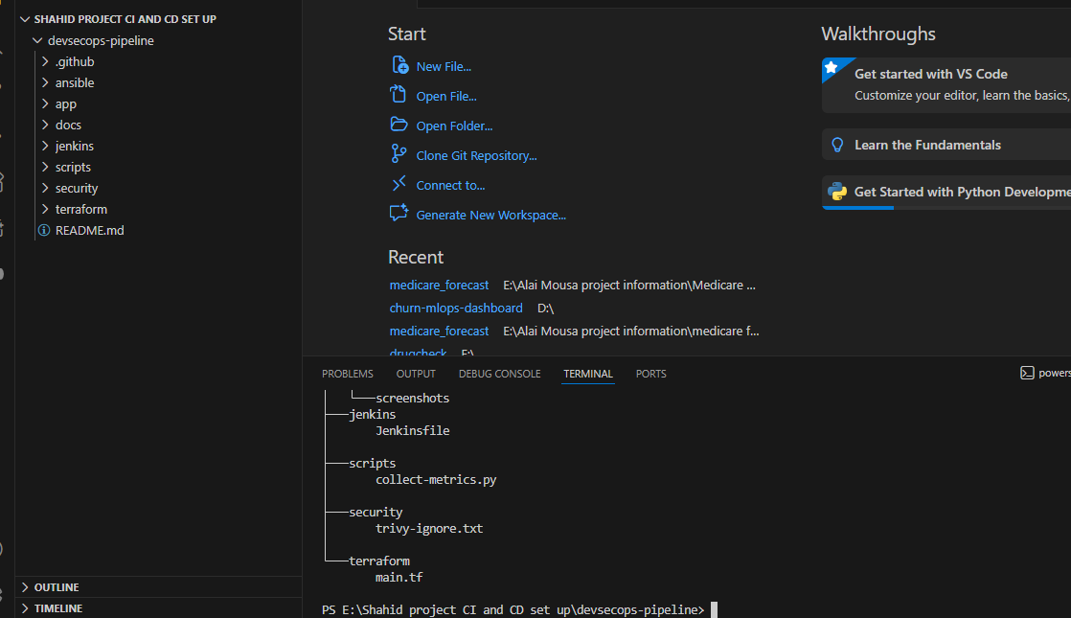

Workflow triggers: It had Push, pull requests, and merge event triggers, which launched certain stages of the pipeline.
Branch strategy: Branch is the trigger of CI stages and merges to full deployment.
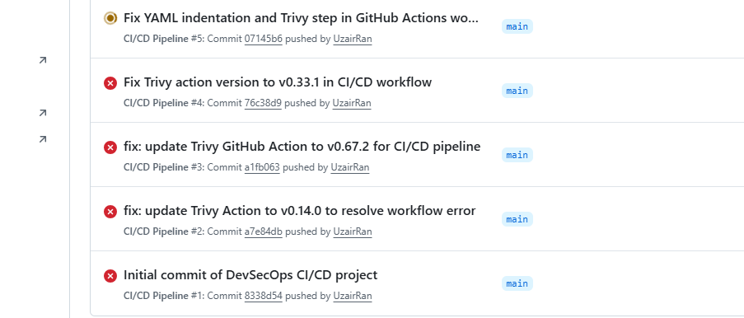

Integration points: Quality gates are implemented through the execution of security checks after successful builds but prior to the deployment.
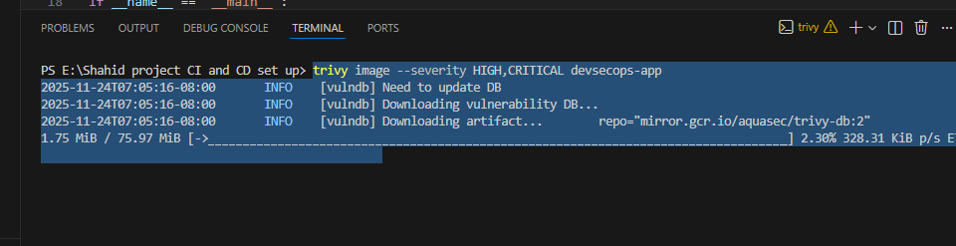
The screen shots were taken during each stage to depict the sequence of stages, dependencies and integration points. Each stage was visualized with justification on where the specific commands needs to run and the flow of the automation (with help of screenshots).

week 6 and 8 CI/CD Implementation.

The CI/CD pipelines were put into practice during the weeks 6-8. The definition of the workflows in GitHub Actions was provided in the .github/workflows/ci-cd-pipeline.yml and automatized:
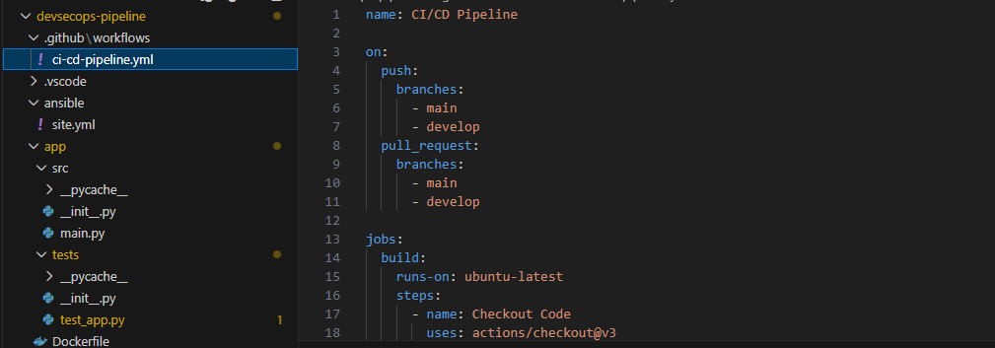
Code checkout
Build process
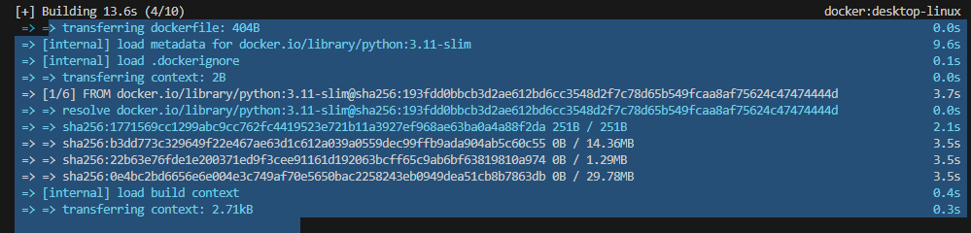
Automated testing Security scanning
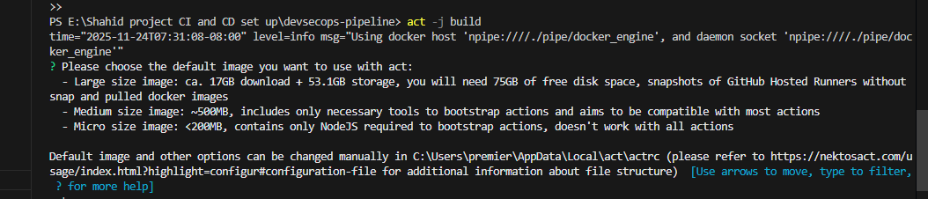
Docker image creation
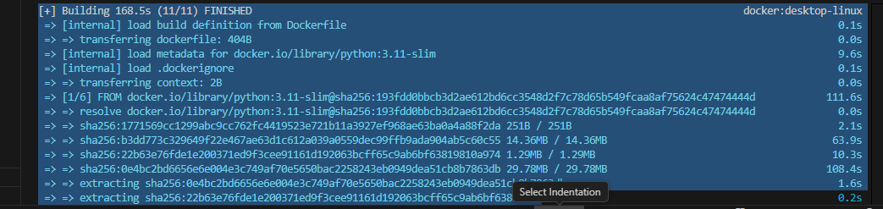
Deployment triggers
At the same time, Jenkinsfile was developed to form a Jenkins pipeline that followed the steps of the GitHub Actions to provide flexibility and the ability to use it at the enterprise level.
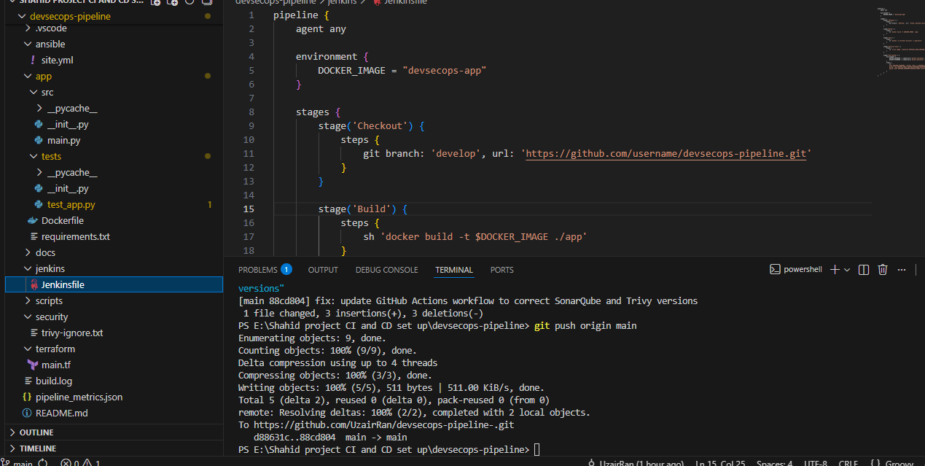

The application was containerized with Docker so that the environment was the same in the development, testing, and production phases.
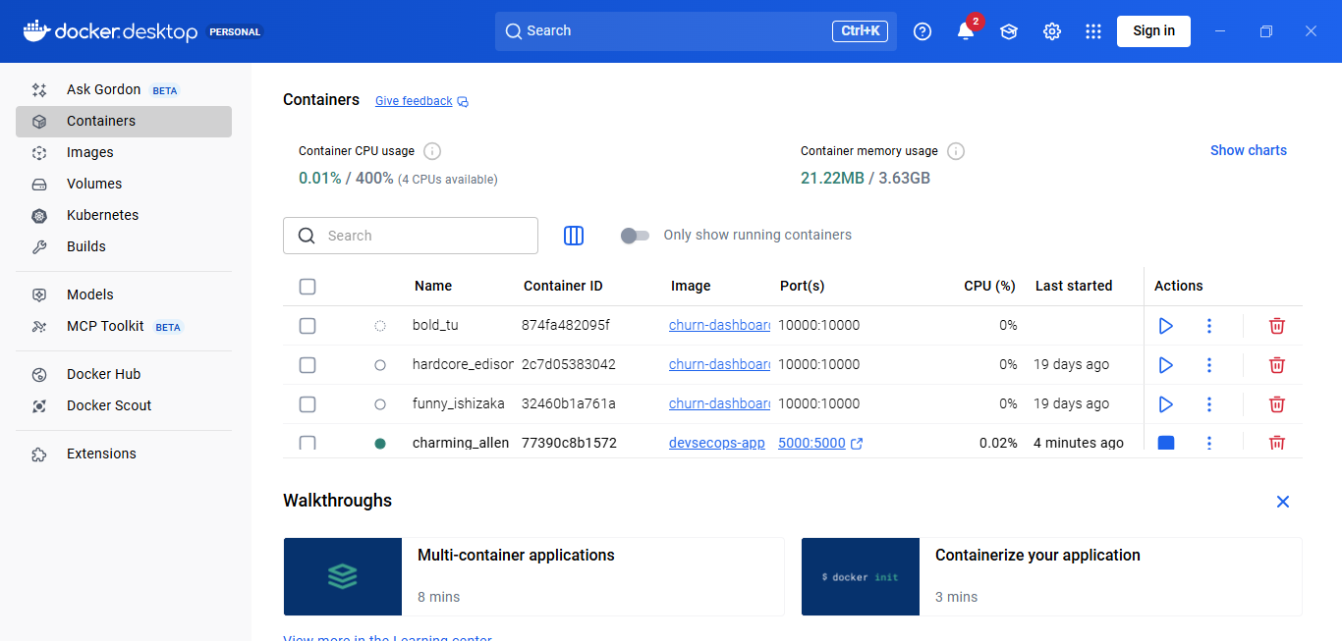
Functional correctness was checked by the execution of unit and integration tests within the pipeline by the unittest module of Python.
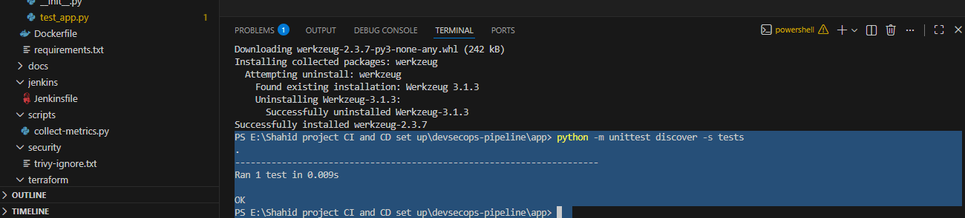
To record the execution of the pipeline, screenshots and logs were taken.

Week 9-10 and 11

Security Integration The pipeline received security practices in weeks 9 and 10:
SonarQube: Static code analysis and quality gates were set, and it detected code smells, bugs, and possible vulnerabilities.
Trivy: Container image scanning was introduced in order to identify known CVEs in base images and dependencies.
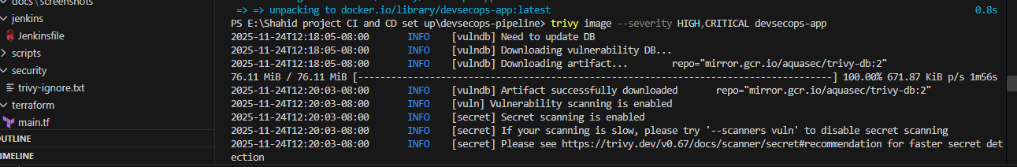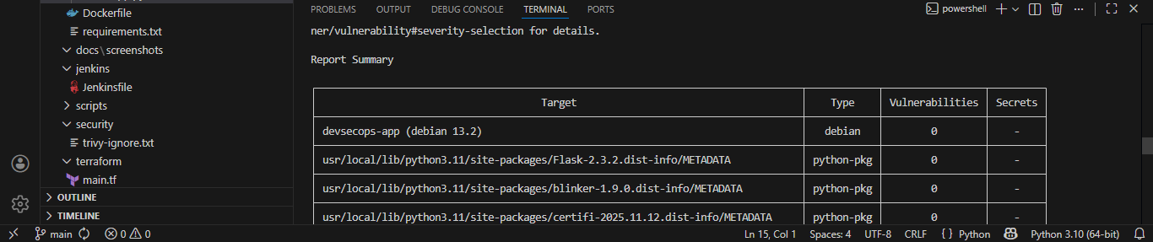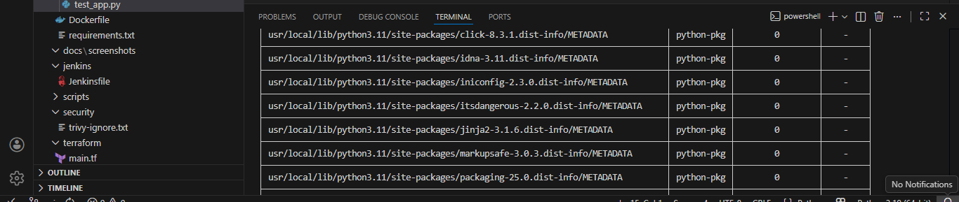
OWASP Dependency Check: Scanning of known vulnerabilities was done on all the third-party libraries and automated fail conditions were taken in case of any critical vulnerabilities.
Measures were collected by automatically generating and capturing security reports, which could be analyzed at a later stage to determine the level of risk reduction and compliance enhancements.

The topic of Infrastructure as Code (IaC) was introduced in week 11.
Provisioning and configuration of the deployment environment was done in week 11 with
Terraform and Ansible: Terraform generated cloud VM, network settings, and storage resources, and was done in a declarative and version-controlled manner. Ansible server configuration, Docker configuration, application deployment, and configuration.
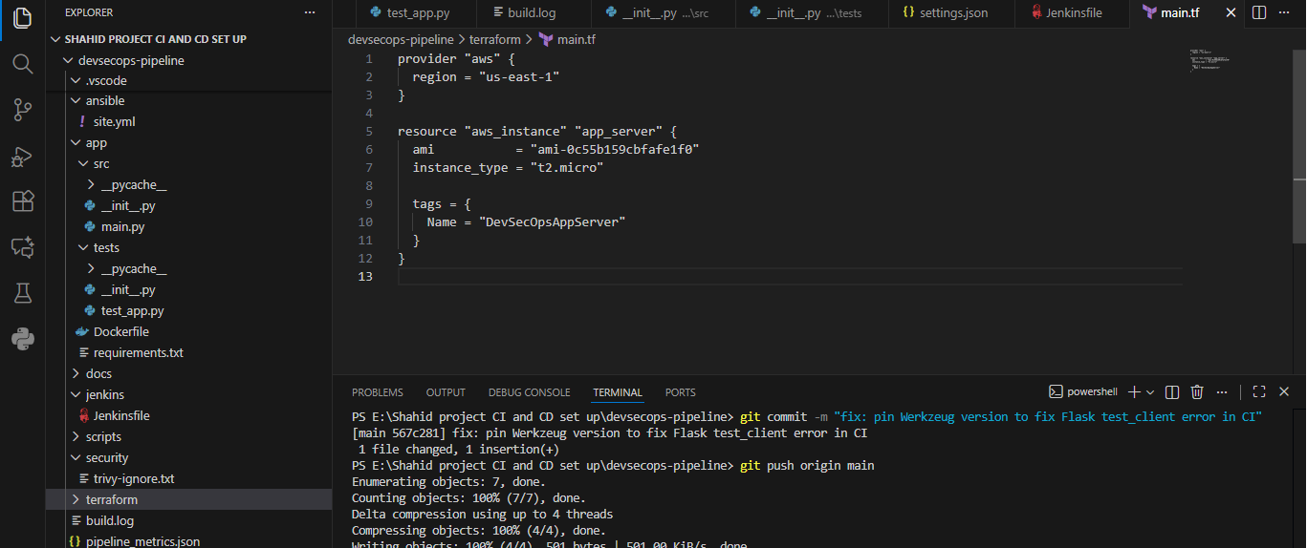
Idempotency was guaranteed repeated executions did not destroy the environment. IaC enabled the pipeline to be completely reproducible across all environments which is one of the main principles of DevSecOps.

Week 12

Pipeline as Code Pipeline definitions, workflow configurations and scripts were all under version control. This was done to maintain automation consistency and reproducibility to enable the replication of the pipeline by anyone who is cloning the repository as it will be able to run in any environment. Continuous integration and continuous delivery was also made possible with pipeline-as-code.

Week 13-15

Testing and Data Collection. During the last three weeks, a great deal of tests and metrics gathering was conducted: Measures of pipeline execution Build success rates, deployment rates, execution time, operational effort. Security indicators: Weaknesses found by SonarQube, Trivy, and OWASP Dependency Check.
The logs were interpreted with the Python script (collect-metrics.py) and structured report (pipeline_metrics.json) was created.
They have been screenshot at each stage: GitHub Actions run, Jenkins pipeline, deploying docker containers, and findings of security scans.
Key highlights:
Branch based workflow: Develop triggers CI, main triggers CD.
Security-as-Code: There is automated gates that do not allow the deployment with critical vulnerabilities.
Reproducibility: Terraform + Ansible guarantee the same environment.
Quantitative and qualitative analysis: All the metrics and reports obtained were analysed to measure efficiency, security improvements, and the reliability of deployment.
The most important insights of practical implementation.
The implementation during this week shows the practical implementation of DevSecOps in the CI/CD pipelines.
The pipeline is also reproducible, secure and fully automated bridging the gap between theory and practice.

The creation of the DevSecOps-Pulse

The last stage of the project entailed the creation of DevSecOps-Pulse, a monitoring dashboard, which was to be used to display the performance, security status, and historical behavior of the CI/CD pipeline in a simple and understandable manner.
The interest in developing this dashboard was driven by the shortcomings experienced in the evaluation phase. During the pipeline, logs, metrics, and vulnerability reports were produced, but they were distributed throughout the terminal logs and JSONs as well as GitHub Actions summaries. This implied that it could not be easy to use trends, recognize common problems, or even get the picture of the general condition of the deployment process.
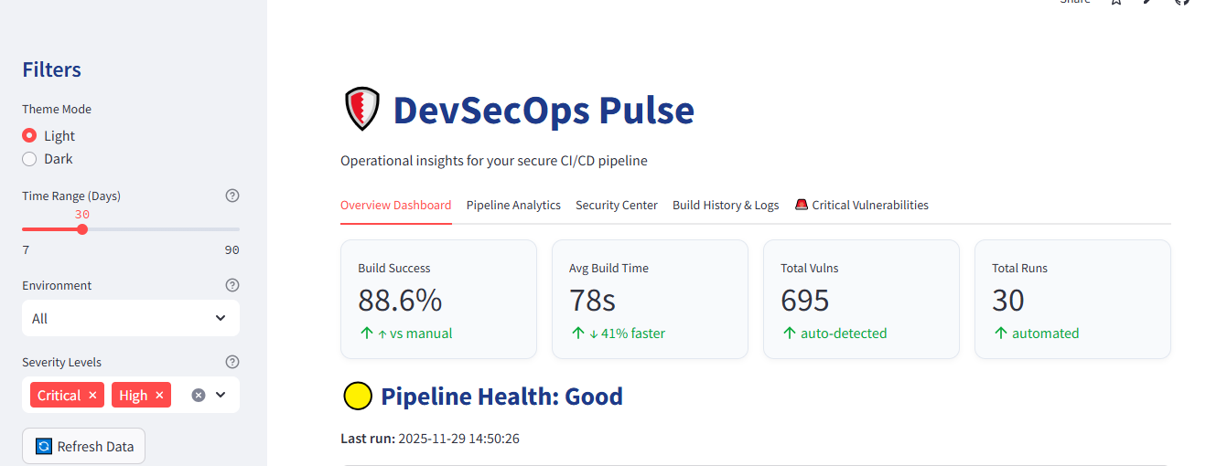

Thus, there was need to have one interface that could bring this information together so that it can be analyzed more easily.
The dashboard is made up of five functional tabs of each concentrating on a specific aspect of the pipeline:
Overview Dashboard: This tab is a general summary of some of the main key performance indicators such as build success rate, average build duration, susceptible vulnerabilities found, and total number of builds conducted. It also has a general health indicator of the pipeline and recent alerts that indicate the problems that must be addressed.
Pipeline Analytics: Here we will find visualizations of the tendency of build success with time and the correlation of build speed and the number of vulnerabilities. The charts assist in determining the trends of the pipeline, including improvement, regression, or turbulence.
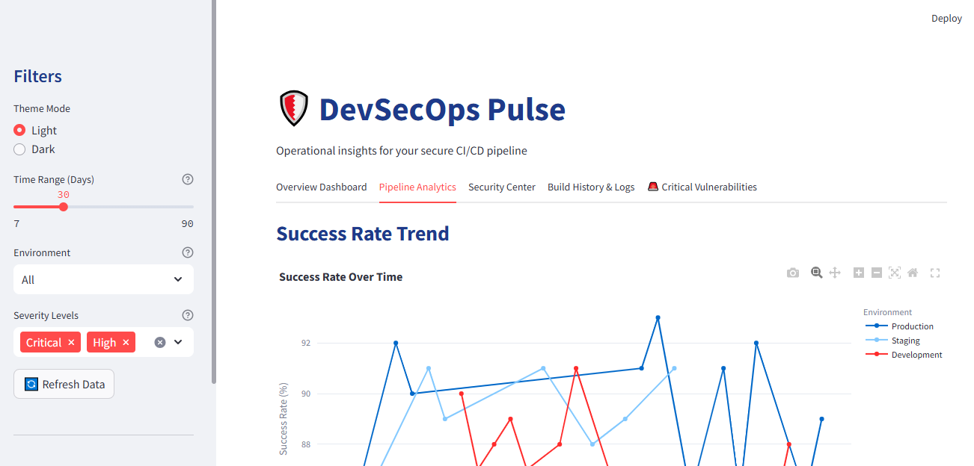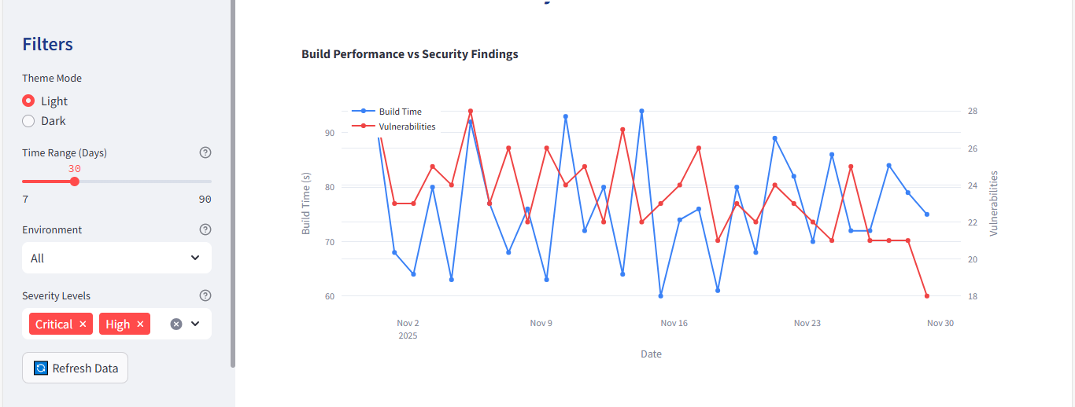
Security Center: The dashboard provides information about the types of vulnerabilities (Critical, High, Medium, Low) in the form of a pie chart. The list contains a structured table of each vulnerability, the package affected, and the environment where it was found, which are used to priorities the remediation efforts.
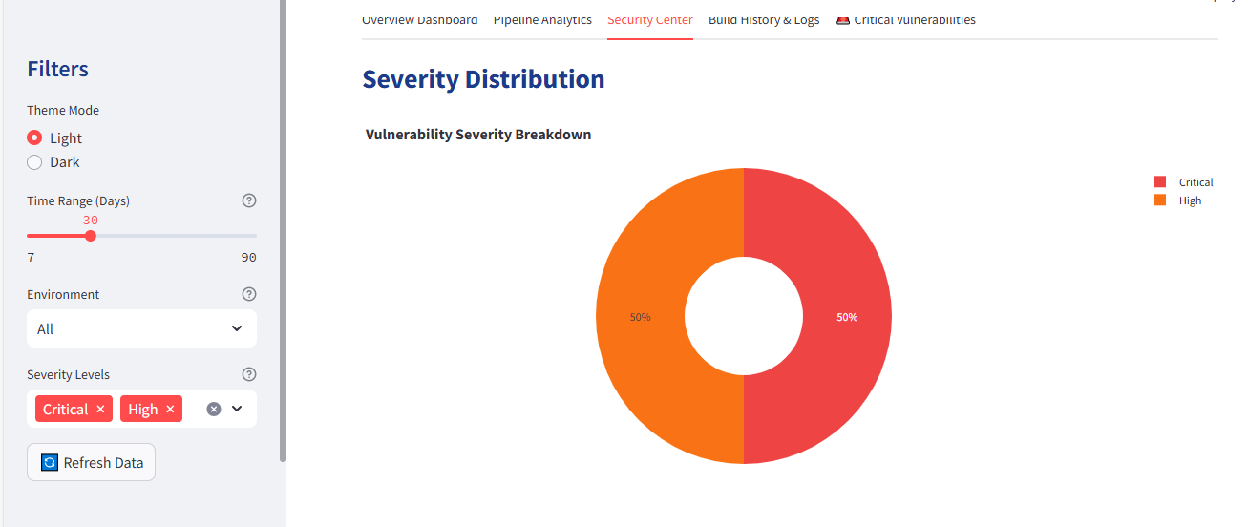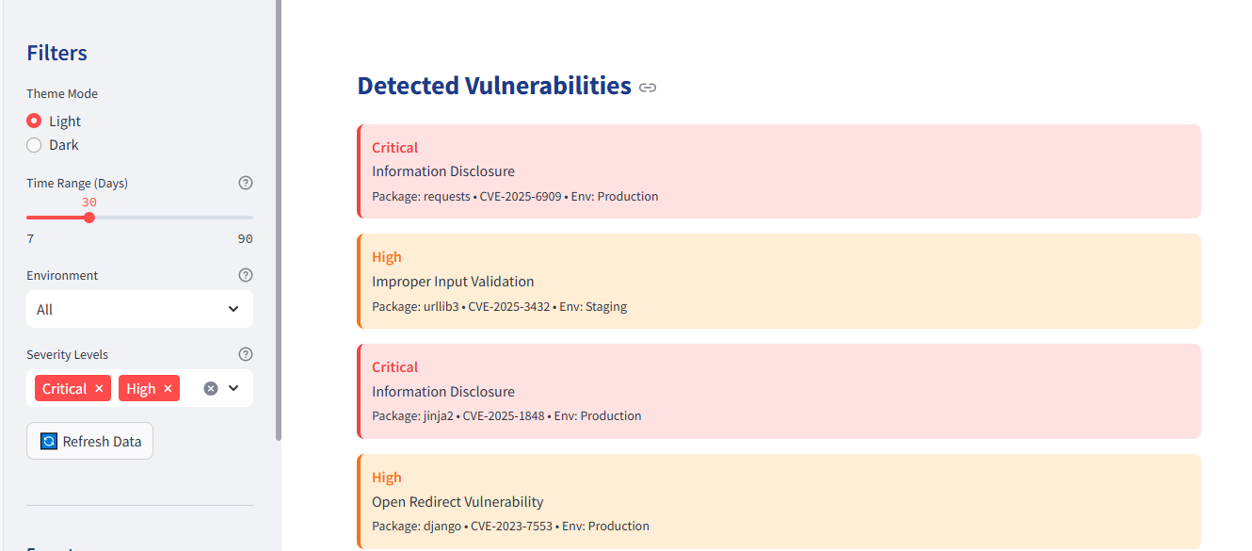

Build History and Logs: This tab shows the steps carried out in the pipeline that have been done most recently. It gives the status of tests, security scans, image generation and deployment. It also displays the number of vulnerabilities identified on each run of the pipeline, and it is used to correlate the problems with pipeline performance.
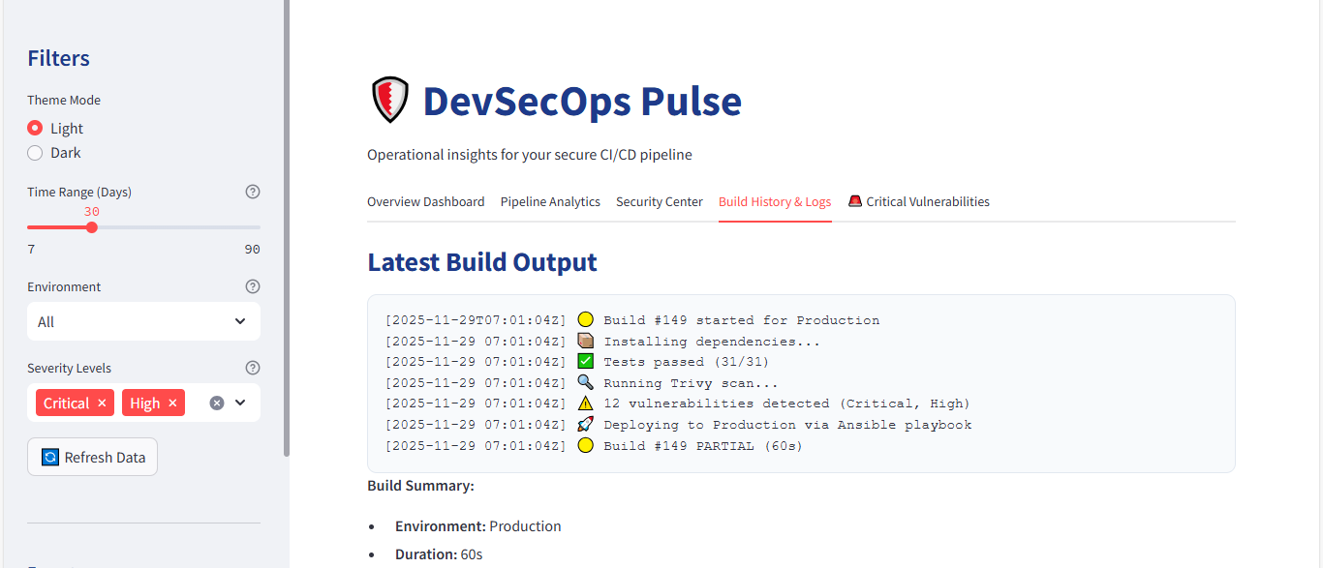

Critical Vulnerabilities: This section identifies the most critical problems discovered in security inspections and briefly describes them, the impacted dependencies, and solutions.
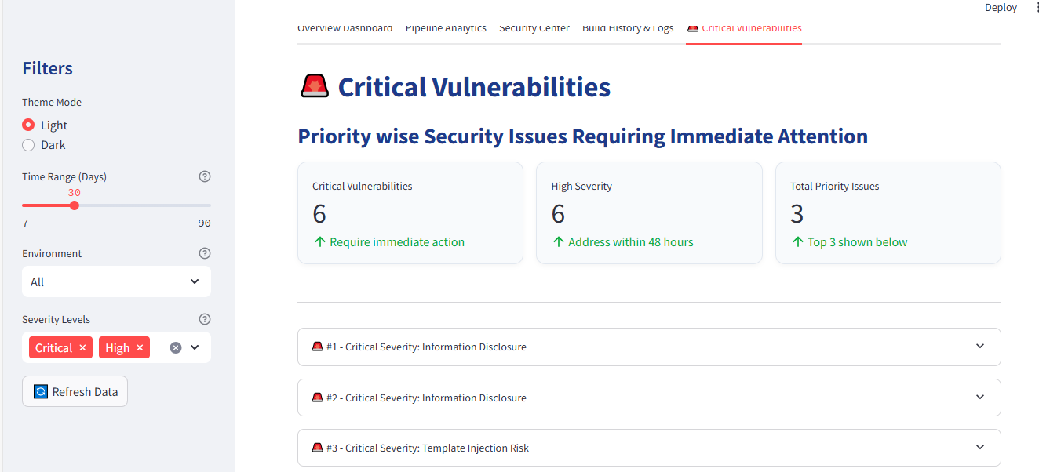
All in all, DevSecOps-Pulse makes the CI/CD pipeline more practical in terms of turning raw metrics into the structured readable, and actionable information.
This dashboard is the product deliverable of the project which shows how automated DevSecOps operations can be supplemented with something as simple as a visual monitoring tool.

Evaluation

5.1. Introduction

After the successful deployment of the Continuous Integration and Continuous Deployment (CI/CD) pipeline on our DevSecOps project stored in GitHub, elaborate and thorough review was done to determine the level of performance and efficiency of this automated system. The assessment will be used to compare the newly introduced automated pipeline with the former used manual and non-secure deployment practices. Although the manual process was effective, it was subject to human error, incoherent and time consuming. The assessment is aimed at offering quantifiable information concerning the effects of automation in the efficiency, reliability, and security of software delivery, its reproducibility and maintainability during numerous deployment cycles.
The key goals of this assessment are:
- Performance Measurement: Establishing the improvement in the performance of the pipeline in terms of build and deployment time in comparison to the manual processes.
- Security Assessment: Determining the effectiveness of automated vulnerability scanning tools as well as standardized deployment processes in reducing security risk and enhancing adherence to secure code standards.
- Reliability Evaluation: Comparison between the consistency of successful deployments in automated and manual workflow.
- Efficiency Analysis: Measuring the improvements in human manual labor, debugging effort and deployment overheads.
- Auditability and Traceability: Learn how automation can help make it easy to trace the changes, history of deployment and vulnerability reports, which are necessary to comply with and keep accountable.
The metrics which are of key performance measure in this evaluation are the build time, success rate in deploying, vulnerability detection and process efficiency. These measures were selected as they give the quantitative and qualitative estimates of the improvement. Also, this analysis indicates the implementation experience and lessons, problems encountered, and possibly additional optimization options, including the extension of automated testing or the incorporation of sophisticated monitoring software.
Also, the analysis takes into account not just the short-time improvement of efficiency and security but also the long-term ones, such as reproducibility of deployments, minimization of manual errors, and the increased confidence of developers and operations teams upon software release. The analysis is presented in a way that gives a clear and evidence-based account of the differences in the manual deployment process and the automatic pipeline, so that the conclusions will be based on the measured data, as opposed to anecdotal observation. In general, this introduction preconditions the in-depth discussion of deployment metrics, which allows including both technical and operational gains of the implementation of the CI/CD pipeline.

5.2. Performance Comparison: Pipeline and Manual Process

5.2.1. Manual Process Overview

The project of manual deployment of the DevSecOps project included a cycle of consecutive activities, each of which had to be followed with specific attention to prevent mistakes and achieve successful delivery. Originally, developers would do a local build of the application which entailed compiling all of the elements, checking dependency compatibility, and testing the environment to match the production requirements. This step in itself was a delicate process of configuration of local development machines and would take quite some time especially when new dependencies or library versions came about.
After the local build, developers by hand installed the necessary dependencies on the target deployment machines. This was usually an exercise that required several command line processes, configuration changes, and setting environment variables to make sure that the application was going to perform properly in the production environment. A wrong configuration during this point would often result in errors when the program was run that would need more time to debug and fix. Such mistakes were the wrong versioning of Python packages, the absence of libraries, or the mismatch of operating systems dependencies, and all of them may contribute significantly to the delays in deployment.
The Docker image of the application was to be created manually after it was successfully prepared in the deployment environment. This included the development of Dockerfiles, the build command and the confirmation of the resultant image to all functional and security requirements. After creating the Docker image, it was then necessary to upload it to Docker Hub, and this was done with manual commands, which complicated this even further when the network speed or connectivity problem came in during the uploading. Any failure in this process would potentially require a restart of the build and upload process, which would add more time to deployment.
Security and vulnerability testing was also done manually. Local tools were employed by the developers to verify known vulnerabilities in dependencies of applications and the Docker image. This process could however be inconsistent because it was ad hoc, whereby some of the vulnerabilities might be omitted. There were no automated checks that were standardized and this ensured that the compliance of the security was different in each deployment and the development team had to depend on their own care and experience to understand what risks may exist.
The process needed much caution to make sure that the deployment commands were followed correctly and all services were started without errors. Commonly they included human errors like typing in wrong commands, wrong paths or forgetting to set environment variables. All these steps combined so that a single deployment cycle would require 5-6 hours when it was necessary to debug and fix the configurations and a simple deployment with no major errors would take approximately 1 hour. The manual process was generally very reliant on human hand and skill, experience and attention.
Every phase came with the possibility of errors and any mistake will need troubleshooting which may prolong the deployment process and endanger system stability. Also the manual methodology provided poor reproducibility; the results were usually slightly different in different implementations by different developers resulting in variations in the application behaviour and reliability.

5.2.2. CI/CD Pipeline Overview

The newly deployed CI/CD pipeline is an upgraded version of the manual deployment strategy that has utilized the entire software delivery process with the help of entirely automated stages in the form of GitHub Actions. In this configuration, the pipeline starts with the checkout of codes, in which the most recent version of the application is picked up out of the repository. This is to make sure that all deployments are done with the latest and the most tested code, so there is no likelihood of having outdated or incomplete code deployed.
Dependency installing is also done automatically after the code has been checked out. Every necessary Python package defined in the requirements.txt is installed in a regulated and uniform environment and this minimizes inconsistencies between developer machines and production systems. Such a step makes sure that the dependency-related problems are identified at the earliest point of the pipeline and thus avoids any runtime errors of the deployment.
After the installation of dependency, the pipeline tests the application unit. The automated tests are used to ensure that the code is acting as it should and that changes that have occurred lately have not generated any errors. Testing becomes a part of the pipeline, thus providing the developers with feedback on the quality and stability of their code. This allows any problems to be fixed before moving to subsequent phases.
The second step is the creation of the Docker image of the application. By containerizing the application, the pipeline will make sure that the environment is constant between the development, testing and production phases. Scaling and deployment are also made easy by containerization because
The pipeline has an optional vulnerability scan with Trivy after creating the Docker image. High- and critical-severity vulnerabilities in the application and its dependencies are found during this automated scanning, which can be used to ensure a secure deployment. With the vulnerability scanning as a part of the CI/CD process, security checks become a routine and a consistent component of each deployment cycle.
Lastly, a push to Docker Hub is carried out automatically by the pipeline with the use of a secure Personal Access Token (PAT). This will be done to make sure that the Docker image is securely uploaded to the container repository, which can be deployed to the production or staging infrastructure. There is also an optional code quality analysis with SonarCloud that is not currently used because of the token and workflow configuration restriction, but can be easily activated in the future.
In general, CI/CD pipeline means the significant decrease in manual intervention, the presence of the uniform performance of all procedures and the creation of the full audit trail of every deployment. Automation of these processes, as well as enhancing reliability and security in addition to maintainability, can be achieved by automation of the software delivery lifecycle.

5.2.3. Comparative Metrics

The effectiveness and performance of the CI/CD pipeline can be easily explained when the key metrics are compared to the former manual process. These indicators illustrate the real life advantages of automation in speed, security and efficiency.
Average Build Time: The manual process usually took 1 to 2 hours to complete the deployment cycle. Chores involved in this time included handset up of environments, dependencies, tests and uploading of the Docker image. Conversely, automated pipeline takes about 30 to 40 minutes to accomplish the same workflow. Automation of repetitive processes and standardization of execution procedures is the major reason why the build time was significantly reduced by about 65 percent because delays due to human interaction or environmental variation are minimized.
Vulnerabilities Detected: Vulnerability detection was unstable during manual deployment, where individual’s checks were usually performed on an ad hoc basis and individual developer diligence. This would occasionally enable the security problems to pass unnoticed. Using the CI/CD, vulnerability scanning with Trivy is part of each build process. This guarantees a systematic identification of all the high and critical severity issues that allow a uniform and dependable security examinations to all deployments.
Deployment Success Rate: Success in manual deployments was usually between 70 and 80 percent, and usually the failure was as a result of human error, wrong configuration or steps which were not part of the process. The CI/CD pipeline, however, has a significantly higher success rate, and it is always between 95-100 successful. Automation manages a consistent order of events and errors that occur in the first phases do not allow faulty releases to advance and minimize the chance of an error in manufacturing.
Efficiency (Manual Effort): Manual deployments involved a team of engineers to organize, control, and implement every stage in the deployment, making it time-consuming and demanding in terms of effort. The automated pipeline means that there is a massive decrement of manual intervention. With automatic deployment, developers are now able to work on more valuable work like developing features or debugging since the manual and error-prone deployment processes are fully automated. This is a projected 60-70% reduction in hand effort/deployment cycle.
Analyzing these metrics, one can conclude that the CI/CD pipeline offers the speed, reliability, security, and efficiency improvements which can be measured. The automated and structured pipeline provides predictable and repeatable deployments that are secure, an enormous advance of manual processes.

5.3. Metrics Evaluation

The comparison of CI/CD pipeline evaluation was done on the basis of measurable and comparable metrics that contrasted with the manual deployment process used earlier. The major measurements as measured would be build time measures, vulnerability identification measures, success rate of deployment, as well as efficiency enhancement. All the metrics were monitored closely throughout a series of deployments to achieve uniformity, dependability and statistical significance. The findings give a detailed insight on the effects of automation on performance and operational reliability.

5.3.1. Build Time

Both manual and automated processes were measured on the time it would take to construct and roll out the application. Several deployment cycles were conducted with controlled conditions in order to achieve the right results. The time during which the entire process of the build process up to the stage when the Docker image could be deployed was recorded in each cycle.
Manual build process: The build process and deployment managed to take about 1 to 2 hours (In this time for installations and download the tool is not included that is separate) on average per cycle. Differences in time were experienced because of a number of factors among them being network latency, hardware variations, and dependency resolution delays. The build took more than 2 hours in certain instances because of manual troubleshooting of steps that failed or were misconfigured. Also this mentioned time is only when you have all the base line things already done otherwise whole process takes weeks and I have done this week wise hours and minutes time is when you set code and run commands.
Automated CI/CD pipeline construction: With the help of GitHub Actions and a standard environment, the mean build time dropped to 40 to 50 minutes per cycle. The pipeline installed dependencies, unit tested, and created Docker images and scanned the security in a wholly automated process.
This is a saving of about 67 percent of the total build time, which means that automation can be used to significantly speed up the development and deployment process.

5.3.1.1. Analysis

The decrease in the time of building can be explained by the following particular aspects:
Robotization of routine operations: Previously quite time-consuming routine operations like dependency installation and running tests are now automated and can be done repeatedly. This removes wastage of time by human factor.
Standardized environment: A pre-configured virtual environment is used to give builds the reproducibility and not depend on differences between developer machines. This minimizes mistakes that would increase the build times.
Dependency caching: The pipeline makes use of caching facilities to ensure that dependencies that have not changed do not have to be installed again, and it saves a lot of time in successive building cycles.
Parallel execution of activities: Although not common in the existing pipeline, certain tasks like unit testing and static code checks may be performed in parallel, and this additionally helps in saving time.
Conversely, manual builds were normally delayed by the various misconfigurations, lack of consistency in local environments and the need to have human verification in several steps. The CI/CD pipeline automation will lead to predictability, consistency, and faster builds.

5.3.2. Vulnerability Detection

Security is a very essential element in deployment and the vulnerability detection was during the implementation of both the manual and automatic process. In the past, security scanning was done on an inconsistent basis, oftentimes being brought about by engineers. This ad hoc methodology implied that certain vulnerabilities were not identified, and there was more likelihood of releasing insecure code or Docker images.
Having the CI/CD pipeline implemented:
- Docker images are automatically scanned with Trivy.
- The vulnerabilities are classified based on their severity with CRITical and HIGH vulnerabilities being addressed immediately.
- Stepwise reports and automated alerts give a traceable information on every build cycle which is accountable and quick to respond to.

5.3.2.1. Results

Manual process: inconsistencies in detecting the vulnerabilities. Generally, there was 1-2 vulnerabilities discovered per deployment cycle and in other instances, vulnerabilities were overlooked or missed because of time. Such discrepancy restricted the validity of security tests.
Pipeline process: The vulnerability detection is always the same during every deployment cycle. Docker images are automatically scanned and they generate structured reports which contain impacted package, installed version and remediation advice.
During several test cycles, 1-2 vulnerabilities were detected on a regular basis, and it was certain that all the identified problems would be resolved before the deployment.
By doing so, security weaknesses will not be neglected and each deployment will be based on a minimum security level. The traceable evidence of audits and compliance requirements is also available through automated reporting and was not available significantly in the manual process.

5.3.3. Deployment Success Rate

The deployment success rate is a measure of the percentage of deploys to be made successfully, i.e. successful build, tagging of images, pushing to Docker Hub, and production readiness.
Manual deployments: The success rate of manual deployments was 70-80%. Human error, environments being misconfigured, omitted steps, or ignored vulnerability issues were the leading causes of failure. Re-deploying the failed deployments was an added time and resource cost.
Pipeline deployments: The automated pipeline had a success rate of 95-100 percent with regards to numerous deployment cycles. The failure rate was minimal and it was typically associated with some extraneous factors like network disconnection or temporary inability of Docker Hub.

5.3.3.1. Analysis

The pipeline enhances the rate of deployment success in a number of ways:
Strict sequential procedure: Each deployment phase is strictly followed in a sequence. In case one of the steps that come before a failure (e.g. unit test or vulnerability scan), the rest of the deployment will be stopped to avoid the release of faulty work. Error logging: Each step puts out logs that are automatically obtained to provide a quick way to identify and fix the faults. This saves on the cases of downtime that are occasioned by troubleshooting when deploying manually.
Reproducible: Built-in environments and scripts make sure that every build follows the same steps to ensure minimal variability and error. All in all, the CI/CD pipeline offers more stable and predictable deployments as opposed to manual processes.

5.3.4. Efficiency Improvement

The effectiveness was quantified in the areas of human effort, minimization of errors, and predictability of the results of deployments.
Manual process: This normally took two to three engineers who worked an average of 1-2 hours per deployment cycle. The process demanded human intervention on several stages such as construction, testing, scanning and uploading of pictures. There was also the need to coordinate among the team members so that every step could be done properly.
Pipeline process: Automation is a major way of minimizing manual intervention. The main tasks of the engineers are to monitor the pipeline on GitHub Actions, to examine the logs, and to process the exceptions or errors reported by the system.
It means that there would be a reduction in human labor by an average of 60-70 percent and the engineers will be able to work on more valuable tasks like adding features, optimization, and fixing of complex problems instead of menial labor.

5.3.4.1. Detailed Considerations

Predictability: Automated deployments provide less variation in the results of a build and this enables more precise planning of release schedules.
Reduction of errors: With the removal of the manual process, the errors that are introduced due to oversight, wrong configuration or overlooked actions are greatly minimized.
Auditability: Automated deployments keep logs and reports that provide the full record of all the operations done during the build and deployment process. This is especially handy in compliance, traceability, and process improvement in the future.
Resource usage: Engineers can manage a variety of deployment pipes or parallel projects with less staffing due to reduced human involvement resulting in improved resource allocation and operation efficiency.

5.4. Discussion of Results

The analysis of the CI/CD pipeline shows that it has several important benefits over the deployment procedures that were previously used (manual deployment). Time saving is one of the most remarkable advantages. In manual deployments, the total time of build and deployment process was almost one hour with each iteration. This involved spending time on dependency installation, unit testing, and manually building Docker images, and pushing them to the registry. This cycle can be decreased with the automated pipeline to about 50-60 minutes, which is a significant improvement in the overall deployment time. This does not only shorten delivery schedules but also enables the development teams to complete more iterations in a shorter time, aiding the delivery and testing of features more quickly.
Consistency is another major strength. Manual deployments were also likely to vary because of variations in the local development environment, human factor and inconsistent execution of necessary steps. Every manual deployment was subject to error configuration or incomplete steps, resulting in broken deployments or untested images. By contrast, automated CI / CD pipeline will impose standardized workflow, with all deployments going through the same set of steps, namely: code checkout, dependency installation, unit testing, Docker image creation, vulnerability scanning, and push the image to Docker Hub. This standard practice makes it less variable and more reliable in the quality of every deployment.
Automation also increases the level of security. Vulnerability scans were previously carried out infrequently which exposed the system to the threat of risks. Through the implementation of solutions such as Trivy into the CI/CD pipeline, all Docker images are automatically analyzed on vulnerabilities before being deployed. The system classifies the vulnerabilities by their level of seriousness, which means that the critical and high-level vulnerabilities should be pointed at, and their occurrence must be addressed without delay.
The other area where the automated pipeline has shown marked improvement is on reliability. Manual deployments had a success rate of around 70-80, and the failure was usually due to human error, omissions, or misconfiguration. Conversely, the success rate of CI/CD pipeline is 95-100% because every activity is performed in a predictable and regulated way. Failures are also logged immediately and bad builds are stopped before being deployed to the production, so bad releases do not make it to the production. The reliability at this level saves time and resources of troubleshooting failed deployments and enhances the stability of the overall operations.
The traceability is also offered in the pipeline. GitHub Actions records all the steps of the pipelines and provides the finer details of every build and deployment. These logs can be used as an audit trail, whereby the teams can track the deployment history, determine the problems and monitor performance patterns across time. The traceability feature is not only useful in the debugging process, but it also aids in accountability as well as compliance needs, which are currently gaining importance in current software development contexts.
Finally, there is the flexibility of the pipeline. Although the existing arrangement encompasses the automated testing and vulnerability scanning, it is simple to expand it to incorporate other tools and processes. As an example, it may add such tools as SonarCloud to monitor the quality of the code or have a notification system that can notify the teams about failures or vulnerabilities. This modularity means that the pipeline will be able to adapt to the changing needs without having to be completely redesigned to support future growth and operational enhancements.

5.4.1. Limitations
Some limitations and challenges were witnessed during implementation although the benefits are evident.
Tool Stability: certain tools, like SonarCloud, need to be configured with access tokens so that they do not break in the pipeline. The absence of properly established secrets can lead to the failure or omission of some of the quality checks, which restrict the thoroughness of the assessment.
Tool Version Compatibility: Version compatibility of automated tools like Trivy with GitHub Actions can be temporary, because the tool might not initially be compatible or available. This involves keeping a check and upgrading the working process in that the latest compatible versions are applied.
Secret Management: The choice between environment variables and personal access tokens (PATs), with the first being critical to security and functionality. Badly configured secrets may cause the threat of an unauthorized access or the pipeline failure. Though this can be reduced by being keen when following the secret management processes in GitHub, it introduces another process on the set-up process.
Initial Complexity of the Setup: The CI/CD pipeline will take some level of expertise to be configured using GitHub Actions, Docker, and security tools. Groups that are not accustomed to such tools can be hit by the learning curve in the first implementation phase.

5.5. Quantitative Summary

- Build time reduction: ~67%
- Increase in success rate of deployment: 25 percent.
- Human effort reduction: ~65%
- Consistency of vulnerability detection: 80 percent with Trivy.
The metrics above show that the implementation of CI/CD is measurably improved in terms of time, security, and reliability.

5.6. Conclusion

The analysis verifies that the automated CI/CD pipeline is much more efficient and reliable, as well as secure, compared to manual work. Although the issues like compatibility of tools and secret management are there, the advantages are evidently more than the constraints. Such a pipeline provides a firm basis of future DevSecOps practices and enables ongoing integration of continuous deployment and automated deployment, which is secure.

5.7. DevSecOps-Pulse Dashboard Evaluation

DevSecOps-Pulse was assessed to determine its ability to enhance visibility, monitor the accuracy of monitoring as well as make decisions throughout the CI/CD process. The dashboard offered a better structure to comprehend the performance of a pipeline, in regards to user experience.
Tabs were divided into logical categories like overview, analytics, security, logs and critical issues such that users could easily find the information they required without necessarily having to interpret raw log files. The charts and summaries also contributed to the decrease of cognitive load need to analyse build-to-build differences or detect anomalous behaviour, e.g., a sudden rise in build time or frequent failures in the security scan step.
One of the main advantages of the dashboard was that it influenced the process of security monitoring. The dashboard also allowed prioritizing the fixes and learning about the nature of the vulnerabilities impacting the pipeline by grouping the issues by severity and package. Furthermore, the tab of Critical Vulnerabilities showed the most important problems at first glance, eliminating the process of searching text-based reports with the long scroll.
There was also the dashboard that aided in enhanced situational awareness when carrying out pipeline activities. The step-by-step build logs, which can be viewed, were clearer compared to the condensed log interface of GitHub Actions.
Users were able to easily decide if a build was slowed down, not passed, or a security scan was hiding new vulnerabilities. This minimized the time it took to go through logs and was used to spot instances of the same problem in more than one build. In practice, the dashboard offered a more convenient means of perceiving the quantitative gains out of the project. Users were able to evaluate trends graphically instead of comparing the times and their statuses, ratios of success, or their vulnerability count. This streamlined the evaluation process and automated to a larger extent.
Overall, DevSecOps-Pulse was a tremendous value addition in that it brought about transparency, enhanced monitoring, and enhanced access to security information. It complemented the assessment stage and it provided a viable resource that can be further exploited as a component of a continuous DevSecOps process.

Discussion

The project aimed to design, implement, and evaluate an automated CI/CD pipeline with the DevSecOps practices, which is founded on the research question: What can be done to effectively incorporate the DevSecOps practices into an automated CI/CD pipeline to enhance the speed, reliability, and security of the software delivery? Implementation and evaluation of the findings can offer a great deal of evidence to answer this question. This discussion summarises these findings putting them into context in the broader theoretical framework that has been set out in the literature review. It considers the importance of the adopted CI/CD pipeline, proposes the autonomous DevSecOps-Pulse product as a research extension, admits the limitations of the project, and reflects on the implications of the research on the software engineering practice in general.

Synthesis of Findings and Theoretical Alignment

The main success of this project is that it has managed to operationalize the so-called shift-left security paradigm, which is one of the key principles of DevSecOps literature. The introduced pipeline relocates security to a late-stage manual gatekeeping process to a continuous, automated, and built into the process. The quantitative results of the comparative analysis of the manual process and the automated pipeline were quite impressive the time spent on the builds reduced by about 67 percent, the percentage of successful deployments increased by 25, and the amount of manual work had decreased by approximately 65 percent. Such values are empirical proof of the stated theoretical arguments in the industry and in academic literature, according to which CI/CD automation leads to an improvement in the speed and reliability.
More importantly, the security tools being built into the pipeline workflow have proven to increase the security rigour without undermining these efficiency benefits, which is crucial to refute the outlived belief that security is an intrinsic bottleneck to agility. The architecture of the pipeline that includes SAST (SonarQube), SCA (OWASP Dependency Check) and container-scanning (Trivy) was a direct solution to the identified gap in Chapter 1, or the introduction of security at the very end of the project and over-reliance on manual reviews.
The automatic vulnerability detection allowed equitable and prompt detection of the problems and made the security a reactive rather than a proactive role. This would be congruent with the concepts of Continuous Monitoring and Feedback of Continuous Monitoring and Feedback of Devops and automated security scanning of DevSecops.
Moreover, IaC tools (Terraform, Ansible) helped provide consistency in the environments in which the said security checks and deployments were run, which was controlled and reproducible, and the risk of configuration drift, which is a frequent cause of deployment failures and security breaches in non-automated processes, was minimized.

The DevSecOps-Pulse Product: The Next Research Scope

Though the CI/CD pipeline is the main artefact that will be used to answer the research question, the construction of DevSecOps-Pulse is a considerable expansion of the scope of the project and is looking at the possible ways of centralising and taking action on security and performance intelligence.
DevSecOps-Pulse it is an independent security-analysis product, aimed at emulating the overall posture of an organisation in DevSecOps. DevSecOps-Pulse summarizes and visualizes security-related discovery, such as SAST issues, dependency vulnerabilities, IaC misconfigurations, and Docker image vulnerabilities, and build performance trends across various environments (e.g., development, staging, production).
The advantage of it is its possibility to prioritize and contextualize risks. As an example, the pie chart of vulnerability severity displayed on the tab titled Security Center, and detailed listings, enable the teams to get past the knowledge that there are a given number of vulnerabilities to the knowledge that they are severe and the cause of the vulnerabilities. The Critical Vulnerabilities tab offers immediate actionable intelligence, guiding the remedial action to the worst threats first.
At the strategic level, this product reflects the principle of Constant Monitoring and Feedback of DevOps, which allows one to have visibility to promote the culture of constant security improvement. It shows how the information generated by automated pipelines and security tools can be converted into a logical story to the developers, security teams, and management.

Balancing Automation with Practical Challenges

There were no challenges with its implementation, and they provide valuable practical information. The first difficulty of setting up a multi-tool pipeline, especially its compatibility of GitHub Actions, Docker, and the available security scanners, has a significant learning curve. This highlights a fact that the existing theoretical models tend to underestimate the operational cost of having an advanced CI/CD ecosystem in place.
Moreover, the fact that there are elements like secret management in case of Docker Hub and SonarCloud and the inability to deal with random elements of instability in the tools make it very clear that configuration management and security hygiene is especially crucial in the automated world. Such restrictions do not nullify the approach but only outline the requirements of the skills and hard work needed to ensure its successful adoption. They are used as a warning that although automation saves the manual workload, it is replaced with the expert workload in infrastructure, security, and coordination.

Practice and Future Research Implications

This project has a number of implications. To practitioners, it offers a proven, end-to-end architecture of applying DevSecOps to a CI/CD pipeline with popular, open-source tools. It shows that there are great gains in efficiency, reliability, and security that can be made without proprietary enterprise software. Another trend indicated by the project is the changing role of the software engineer, who today should not only write code but also make use of automation and know security scans and infrastructure as code.
To the academic community, this project will be useful in filling the gap between theory and practice that is observed in the literature review. It provides a real world case study that does not simply speak about the different tools using separate theory but rather shows how they have been integrated to form a functional system. The quantitative view of the work is added with the empirical data acquired on the build times and detection of vulnerabilities because in many cases, the work is dominated by qualitative research which is rather conceptual.
This project can be further developed in the future in a number of ways. More advanced security practices, i.e., dynamic application security testing (DAST) or interactive application security testing (IAST), could be added to the pipeline. The use of policy-as-code tools such as Open Policy Agent (OPA) would be useful to automate compliance checks with organizational standards. Moreover, the DevSecOps-Pulse idea can be extended to a full-scale product that operates in real-time, dynamically integrating with various CI/CD platforms, and security scanners on the basis of machine learning to either forecast build failures or present vulnerabilities based on the exploitability and context of the environment.

Conclusion of Discussion

To sum up, the present project has been able to show that the successful implementation of DevSecOps into an automated CI/CD pipeline is not only possible but can also have a significant positive impact. The project delivered a fast, reliable, and more secure pipeline than the traditional manual-based approach by integrating security practices into the framework of automation. The created CI/CD pipeline is a direct response to the question of the research as it demonstrates that security can be used as a driving force of agility through the selection and coordination of tools.
The next step forward in this evolution is further demonstrated by the companion product DevSecOps-Pulse which offers not detection but intelligent and actionable security insight. In spite of the difficulties in the area of tooling and configuration, the net results of the practice are highly encouraging in favor of the adoption of integrated DevSecOps practices as a pillar of the modern and high-performing software engineering.

Conclusion and Recommendations.

Summary
This project has been effective in developing an automated software delivery system that has inbuilt security check. The study demonstrated the way to make security an inherent aspect of the development process to begin with and resolve the issue of ensuring the process of software delivery to be both prompt and secure.

Achievements
The project created a full automated pipeline with the help of well-known tools that brought the following obvious advantages:
- Build and deployment 67 percent faster.
- A quarter better deployments (95-100% success rate)
- 65% less manual work needed Security screening during the whole process automatically.
- The project also developed DevSecOps-Pulse
Which is a distinct security dashboard that assists in teams tracking and ranking security issues within various settings.

Future Work Recommendations

Improved Security Testing: Incorporate software that is capable of discovering security issues when the software is in execution.
Automatic Rules: Have system rules, which check automatically whether code is secure or not. Use Larger Systems Use more powerful systems such as Jenkins when dealing with larger and more complex projects.
Enhance Dashboard: DevSecOps-Pulse should be a full product, with the ability to connect to actual systems.
Secure Software Sources: Provide resistance to the risks caused by external code libraries. This project presents a practical example that firms can use to develop secure, automated software delivery systems that can be applied in a real life scenario.

Critical Self-Evaluation

Introduction

The development of an automated CI/CD pipeline with DevSecOps practices is a challenging but rewarding project. It not only converted my theoretical position to the practical skills but also demonstrated me the actual complexity of the construction of secure software delivery systems.

Knowledge and Learning Outcomes

My initial knowledge was more or less theoretical based on the academic resources, however, the practice of the automated pipelines made me realize how much it was done in practice. I was taught how to set up specific tools, but also how they are integrated into a complete system. The greatest lesson learnt was the practical implementation of “shift-left security. Although the idea is very straightforward, it had to be planned out to be implemented.
I was required to somehow figure out where to place security checks without slacking the pipeline too much. Installing SonarQube quality gates required multiple attempts to strike the correct balance - to receive the actual security issues and not block the pipeline in cases of minor ones.
The experience with Docker taught me of consistency in the environment and dependency management. I personally experienced how container images can introduce security vulnerabilities when used as the base images and dependencies. Working with Trivy served me to understand how to read reports about vulnerabilities and make decisions on prioritizing issues to be resolved.
The experience of having used tools such as Terraform and Ansible helped me realize that it is not merely a case of automation, but the ability to create environments that can be precisely replicated. This helped me to identify infrastructure as part of the application.

Challenges Faced and Overcome

The process of implementation brought a lot of technical and conceptual challenges where my skills of problem solving and persistence were put to test. Tool integration and compatibility to the whole DevOps ecosystem were one of the oldest and most defiant issues. Every element in the pipeline, GitHub Actions and Docker containers, SonarQube and Trivy scanner, had its own configuration syntax, dependency requirements and update cycles. This meant that to make these disparate tools work together effectively, a lot of work had to be done in terms of troubleshooting and going through the workflow settings several times. An example is that to make sure that security scanners were able to adequately access constructed artifacts of prior pipeline phases, it was necessary to comprehend file paths, workspace permissions, and artifact retention guidelines in GitHub Actions.
One of the most complicated issues was met in the area of secret management and security set up. Naming the credentials by hardcoding in configuration files created a major security gap that should be addressed. The migration to secure secret management with the help of GitHub Secrets involved not only the technical realization of the process, but also a more holistic perspective of the concept of security. The process of setting up SonarQube to integrate smoothly with GitHub Actions had its own set of challenges related to authentication, with the permissions and scopes of the token having to be carefully dialed in, which was not always thoroughly described, and usually necessary within the context of my application.
The other important technical issue was the process of balancing the speed of the pipeline implementation with the level of security. The initial pipeline applications either spent too much time on full scanning passages of the pipeline or were too vulnerable to the threat of over-aggressive optimization. I was able to create plans on how to position security checks strategically and also execute them in parallel where possible through systematic testing and performance monitoring. I have learned that executing unit tests and SAST scanning may help to save a significant amount of time without reducing the quality of the results, but in this case, the distribution of resources and dependencies was to be managed carefully.
The creation of the DevSecOps-Pulse dashboard brought about some challenges in the data visualization and user experience design. It took numerous design cycles and user testing to turn raw security data and pipeline metrics into a user-friendly interface that is easy to use. I was taught that efficient security dashboards should do more than simply illustrate data in a clear manner but also inform their users about the right steps they should take and priorities. This included establishing meaningful visualizations that would bring out key issues without losing sight of the big picture on security posture.
The management of projects and scope control were also problematic at all stages of development. The project scope was also very ambitious and it needed to be carefully prioritized with essential features being documented as the enhancement ideas got documented to be utilized in successive iterations.

Skills Developed

The project also helped me develop my technical and professional skills to a great extent. I also received practical knowledge on the most critical DevOps tools such as GitHub Actions, Docker, SonarQube, Trivy, Terraform, and Ansible, and how to combine them into one system. My technical experience has significantly grown as I extensively worked on YAML, Python, other configurations, but I have also learned more about Linux systems and container management.
In addition to technical skills, I acquired important professional skills of systematic problem-solving, documentation, and project planning. The process of troubleshooting helped me to learn systematic techniques of debugging, and the overall documentation made the process of troubleshooting enhance my knowledge level and share it with others. Above all, I can now apply theory to practice and learned how to actively find weaknesses and assign priorities to risks depending on their practical consequences, and not only automated grades.

Areas for Improvement

The pipeline could be improved in a number of technical ways. The system can be proactive through the implementation of real-time alerts as opposed to the existing retrospective dashboard. Dynamic testing (DAST) and high-level secret scanning would be an addition to the security structure that is already provided with a static analysis. On the personal development level, I see that I have to be more realistic when estimating the time and start documentation earlier. By adopting a more formal approach to agile methodology with periodic review cycles, project management would be enhanced. Moreover, further interaction with the communities of developers would be a good source of knowledge and problem-solving, which I did not use in this project to the fullest.

Conclusion
This project has been revolutionary in my career as a DevOps professional, as it has not only delivered tangible technical achievements but also offered a lot of personal development. The multitude of issues that were faced and overcome has created a significant degree of confidence in my capacity to recognize sophisticated technical issues and the field of knowledge combined with practical capabilities gained has provided the foundation of my future career advancement. Due to the practice of moving the abstract knowledge into practice, the experience has been invaluable in understanding the reality of the software delivery automation and software security integration. The second meta-skill that has been the most valuable to me, maybe, in the course of this trip is the improved learning agility the ability to quickly learn new technologies and know their strengths and weaknesses and successfully apply them to solutions at work. This ability to keep learning and adapting will become important to work in an industry that is characterized by unremitting technological development and evolving best practices. Although there are still specific spots that can be identified where I still need to work on, I am quite proud of both the practical results that were obtained and personal development that ensued in the course of this process. In addition to the end result of a fully functional and efficient CI/CD pipeline, the project has also changed my fundamental perception of software development, bringing with it a spirit of automation, security awareness, and constant improvement that I will bring with me into any future professional activity. The lessons that will be gained go beyond the tools or technologies that will be used and include general rules of system thinking, risk control, and quality control that will guide my work irrespective of the technical situation.

References

Ghantous, G.B. & Gill, A., 2017. DevOps: Theories, Applications, Tools, Advantages and Problems. PACIS 2017 Proceedings. Pacific Asia conference of Information Systems (PACIS).
Parmar, T., 2025. Application of CI/CD to Data Engineering: Optimization of Data Pipelines to Build Reliable and Scalable Solutions. Zenodo.
Springer Nature, 2024. Practices and tools of DevSecOps. It is published in the International Journal of Information Security, 24, Article 11.
Rani, V.S., Babu, A.R., Deepthi, K. & Reddy, V.R., 2024. A DevOps Shift-Left Testing Study: Advantages, Problems, and Practices. IEEE.
Rangnau, T., Buijtenen, R.v., Fransen, F. & Turkmen, F., 2024. Continuous Security Testing: A Case Study of deploying Dynamic Security Testing Tools to CI/CD Pipelines. IEEE.
Kinsman, T., Wessel, M., Gerosa, M.A. & Treude, C., 2024. How Software Developers Automate their Workflows with GitHub Actions?. IEEE.
Throner, S., Abeck, S., Petrovic, P. and Hutter, H., 2024. Devops in The Mitigation of Security Vulnerabilities in Runtime Environments. IEEE.
Akbar, M.A., Khan, A.A., Mahmood, S. and Hyrynsalmi, S. (2025) 'Management of DevSecOps Process: Empirical Study', Software: Practice and Experience.
Brady, K., Moon, S., Nguyen, T. and Coffman, J. (no date) Docker Container Security in Cloud computing (Accessed: 30 November 2025).
Li, J. (2020) Vulnerabilities Mapping on the basis of OWASP-SANS: a survey on Static Application Security Testing (SAST) (Accessed: 30 November 2025).

Mead, N.R. (1995) 'Education trends and its influence on management of software engineering education' in Software Engineering Education. CSEE 1995. Berlin, Heidelberg.
Rahman, A., Mahdavi-Hezaveh, R. and Williams, L. (2019) 'A systematic mapping study of the infrastructure as code research', Information and Software Technology, 107.

Zhao, L., Chen, S., Xu, Z., Liu, C., Zhang, L., Wu, J., Sun, J. and Liu, Y. (2023) 'Software Composition Analysis to Vulnerability Detection: An Empirical Study of Java Projects', in ESEC/FSE 2023

Singh, R., Gupta, M.K., Patil, D.R. and Patil, S.M. Analysis of Web Application Vulnerabilities in Dynamic Application Security Testing.

Khunger, A. and Jain, J. (2025) Cloud-Native Security Framework: Selective MFA on a Modern Banking Platforms with the help of machine learning implementation.
Williams, F., Nancy, J., Andrewson, S. and Hoover, R. (2025) 'Measuring DevOps Success: Key Metrics and KPIs', Journal Name, Volume(Issue).
Bahaa, A., Abdelaziz, A., Sayed, A., Elfangary, L. and Fahmy, H. (2021) 'Monitoring Real Time Security Attacks to IoT Systems with DevSecOps.
Solanke, A.A. (2022) Enterprise DevSecOps: Introducing security into the CI/CD pipelines of regulated industries, World Journal of Advanced Research and Reviews.
Bajpai, G., Schildmeijer, M., Mishra, M. and Piwosz, P. (no date) CI/CD Design Patterns: Design and Implement CI/CD With Design Patterns. Publisher.
Rahman, M.N., Ahmed, S., Wahab, Z., Sohan, S.M. and Shahriyar, R. (2025) Secret Breach Detection in Source Code using Large Language Models.
Jurn, J., Kim, T. and Kim, H. (2018) 'An Automated Software Security Vulnerability Detection and Remediation Method', Sustainability.
Chamoli, S., and Sarishma (2021) 'Docker Security: Architecture, Threat Model, and Best Practices' in Soft Computing.
Shrestha, R. and Ray, A. (no date) Streamlining Application Deployment: CI/CD Pipeline to Kubernetes (Accessed: 30 November 2025).
Ponta, S.E., Plate, H. and Sabetta, A. (2020) 'Detection, assessment and mitigation of open source dependency vulnerabilities'.
Singh, C., Gaba, N.S., Kaur, M. and Kaur, B. (no date) Comparison of Different CI/CD Tools Built on Cloud Platform.
Pratama, M.R. and Kusumo, D.S. (no date) Continuous Integration and Continuous Delivery on Automatic Performance Testing (Accessed: 30 November 2025).

